**Flight Reservation System**

Xhesila Shaha

Department of Information Technology, Marymount University

IT-540 Enterprise Data Management and Analysis: Course Name

Dr. Faleh Alshameri

Dec. 02, 2020

**Table of content**

**Introduction** 5

**Vision** 6

**Scope of the project** 6

**Hardware requirements** 7

**Software requirements** 8

**Network requirements** 8

**Project management GANTT chart** 9

**Pert Chart** 9

**Entity Relationship Diagram:** 12

**Data Dictionary** 12

**Prototype:** 16

**Project Challenges** 19

**Queries:** 20

**Queries Output Screenshots:** 22

**Appendix (script):** 26

**Screenshot:** 36

# **Introduction**

We are the IT department of HermesWings Airlines.

HermesWings Airlines was founded in 1950 by a group of airforce veterans. The airline has modest operations, with a fleet of 20 airplanes connecting mostly East coast cities. Business has been steady for the past 30 years. The company sources of income are cargo, and in a smaller amount passenger transportation.

For the past five years, there was a desire to transform the business model to mostly passenger transportation, significantly increasing the number of passengers the airline transports. A group of investors agreed to finance the scale up of the airline operations to compete with the big domestic airlines such as Southwest and Delta.

We were tasked to transform the airline's paper heavy operations into a fully digital system with a strong database. A database system will help HermesWings Airlines be more efficient and save resources on operations. At the same time, the new system will make operations safer.

HermesWings has been operating on the East Coast for 70 years. The main offices are in Arlington, Virginia. Our activity has been limited as we provide services in a small number of cities; but we are working on expanding our services and capacities to the fullest. Innovation is a must for our company to be the leader in the airline market.

The company’s operations were all recorded on paper. The internal audit suggested a new system that includes the digitalization of data and operations. As expected, this process will change the staff and customer experience.

The flexibility and accessibility of the new system will make the overall process faster and significantly more efficient. The data generated by the new system will provide a great advantage for generating useful reports. These reports will provide a clear view to the company’s overall performance and which areas should be improved/reinforced.

# **Vision**

As every business in the market we do consider our company a visionary team of passionate people that try their best to provide a smooth, relaxing experience for the customers. We do have a moto that reflect our ambition for the future: “The technology is in a non-stop run, it's time for us to be one step ahead of what is offered in the market.”

# **Scope of the project**

In order to transition this growing company from the current airline paper system to a fully digital and database system, there are several key objectives and goals we will focus on:

*Objectives:*

* Develop a user-friendly, organized database with multiple views to allow access to information for each department.
* Ensure referential integrity exist within that database
* Provide efficient hand on training to the pilots and crew members.

*Goals:*

* Increase sales
* Gain and retain more travelers
* Acquire more flights to top travel destination locations.

# **Hardware requirements**

* A Microsoft SQL Database Server  
  The Server should be equipped with a processor clock speed of over 1.5 GHz and a memory of over 512 MB.
* A webserver  
  The server should be equipped with a processor speed of over 1.5 GHz and a memory of over 512 MB.
* Windows Operation systems with Minimum 8GB RAM on the and at least 200GB hard disk

# **Software requirements**

*Software Interface*

The application should run on a Windows/Linux Operating System. Since the application needs a database to store all the data.

The required software for the Airline Reservation System project would be as follows:

* Operating System: Microsoft Windows/Linux
* Web Server is included in the Windows/Linux
* The application is developed in Python Flask and Angular
* Microsoft Internet Explorer (or) Google Chrome (or) Mozilla Firefox for accessing the web application.
* MySQL database need to be installed in windows/Linux

# **Network requirements**

*Required network configuration*

A broadband connection with 100Mbps and above connection is needed to provide fast linkage to the server, thus providing faster service to the user/customer.

# **Project management GANTT chart**

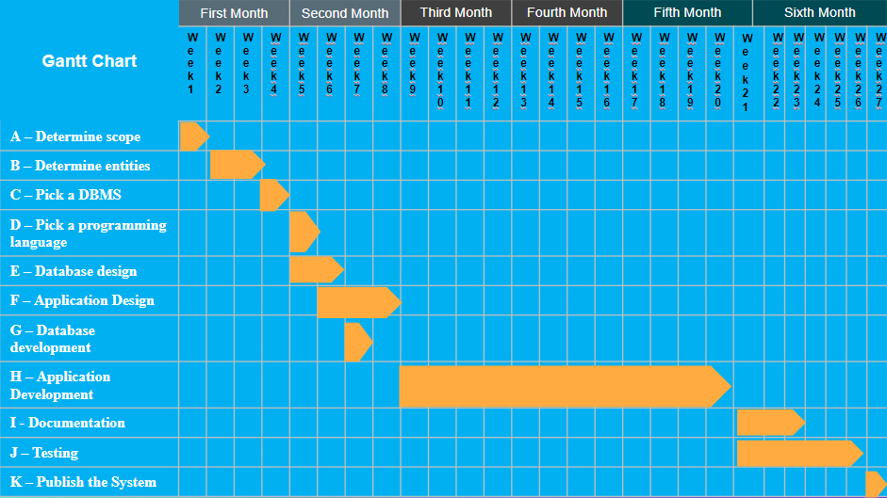Gantt charts are known for their time management usage. They are effective for planning and scheduling projects. Gantt chart has helped us to assess how long each task of the project should take, determine the resources we needed, and plan the order in which our work should be distributed to complete tasks in time for the final deadline.

# **Pert Chart**

As we know, PERT chart is a project management tool used to schedule, organize, and coordinate tasks within a project. It came in hand to analyze the tasks involved in completing the database project that was given to us, especially the time needed to complete each task, and to identify the minimum time needed to complete the total project.

*The strategy used to create the PERT Chart:*

1. Break our project down into 11 tasks.
2. Spot dependencies of each task to the others.
3. Add time estimates for each task depending on the total time available.
4. Plot out your PERT chart according to the completed steps above.
5. We chose our critical path.

|  |  |  |
| --- | --- | --- |
| **Task** | **Duration in weeks** | **Predecessor** |
| **A – Determine scope** | **1** | **None** |
| **B – Determine entities** | **2** | **A** |
| **C – Pick a DBMS** | **1** | **A, B** |
| **D – Pick a programming language** | **1** | **A, C** |
| **E – Database design** | **2** | **C** |
| **F – Application Design** | **3** | **B, D** |
| **G – Database development** | **1** | **E** |
| **H – Application Development** | **12** | **F** |
| **I - Documentation** | **3** | **G, H** |
| **J – Testing** | **6** | **H** |
| **K – Publish the System** | **1** | **J** |

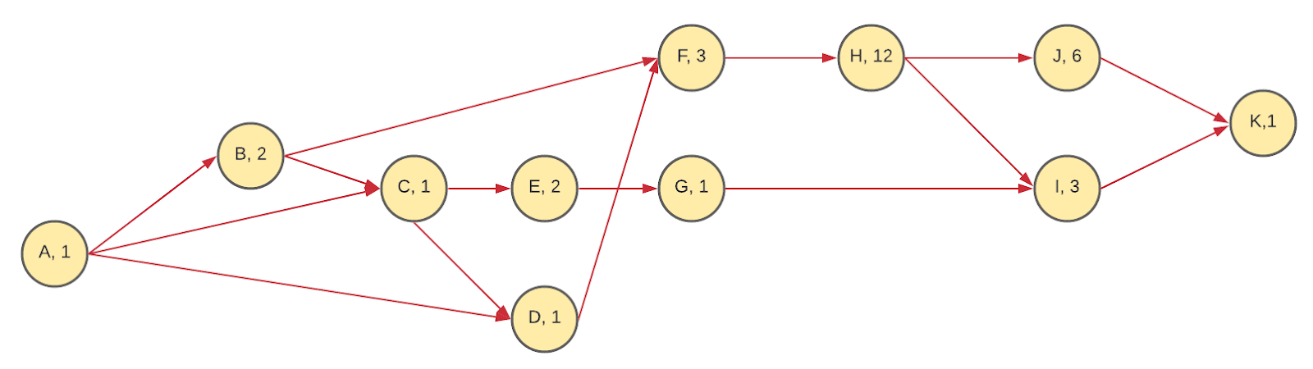

**Critical Path**

P1 = A, B, F, H, J, K = 1 + 2 + 3 + 12 + 6 + 1 = **25**

P2 = A, B, C, E, G, I, K = 1+2+1+2+1+3+1 = **11**

**P3** = **A, B, C,D, F, H, J, K** = 1+2+1+1+3+12+6+1 = **27 Critical Path**

P4 = A, B, C, D, F, H, I, K = 1+2+1+1+3+12+3+1 = **24**

P5 = A, C, E, G, I, K = 1+1+2+1+3+1 = **9**

P6 =A, C, D, F, H, J, K = 1+1+1+3+12+6+1 = **25**

P7 = A, C, D, F, H, I, K = 1+1+1+3+12+3+1 = **22**

# **Entity Relationship Diagram:**

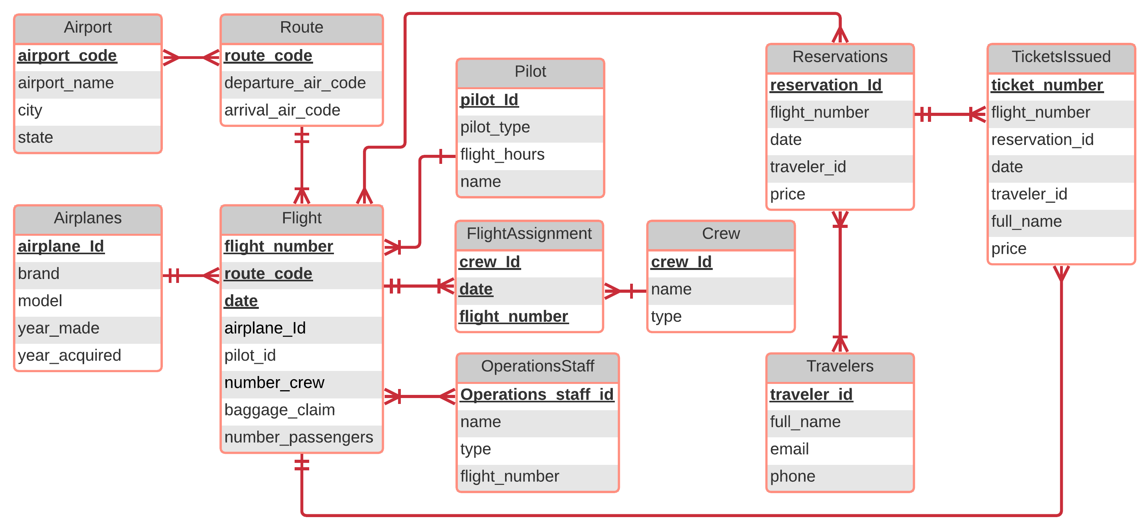

# **Data Dictionary**

|  |  |
| --- | --- |
| **Airport** | A complex of runways and buildings for the takeoff, landing, and maintenance of civil aircraft, with facilities for passengers. |
| **Airport Code** | Unique ID that specifies a specific airport in a specific geographical location |
| **Airport Name** | Name of airport complex, airport code is usually the abbreviated version |
| **Airplane** | A powered flying vehicle with fixed wings |
| **Brand** | Manufacture who built the plane |
| **Model** | Series of airplane |
| **Year** | The year airplane was completed in building. |
| **Year Acquired** | Year airline company added plane to fleet |
| **Crew** | Employees assigned to a specific department within airline |
| **Crew ID** | Unique ID number assigned to each person within department |
| **Name** | Unique name of crew member |
| **Type** | Department member assigned to. |
| **Flight:** | Airplane taking action or in the process of flying through the air |
| **Flight Number:** | Unique number to specify informational details about airplane and travel information. |
| **Route Code:** | Unique number that calculates how the airplane travels from departure airport to arrival airport |
| **Date** | The day of the month or year as specified by a number |
| **Price ID** | Unique identification that reflects the price |
| **Airport departure** | Airport location of where the place is scheduled to depart |

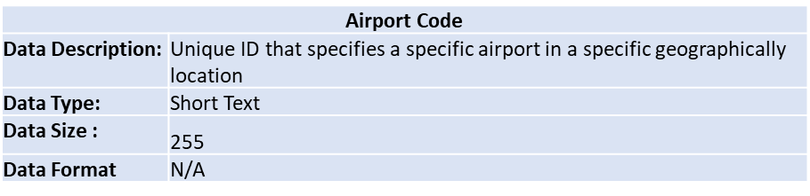

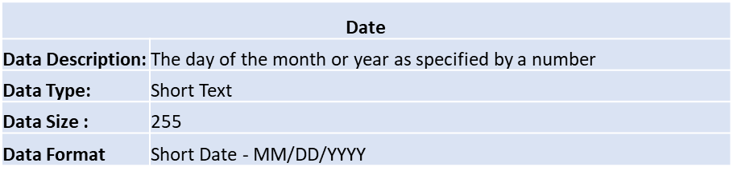

|  |  |
| --- | --- |
| **Airport arrival** | Airport location of where place is scheduled to arrive |
| **Baggage claim** | The area in an airport where arriving passengers pick up their checked baggage. |
| **Operation Staff** | Employees who work in the operations department |
| **Operation staff ID:** | Unique ID number assigned to each person within operations department |
| **Gate** | Portion of airport when travelers board and depart airplane |
| **Pilot** | A person who operates the flying controls of an aircraft |
| **Pilot ID** | Unique Id specific to each pilot |
| **Pilot Type** | Specific field the pilot is certified in, commercial or airline |
| **Experience** | Amount of training hours and work history |
| **Reservations:** | Confirmation of purchase of reserving airline ticket |
| **Reservation ID** | Unique number specific to purchase of reservation of airline ticket |
| **Travelers** | Customers who have purchased a airline ticket |
| **Travelers ID** | Unique number specific to each traveler on airplane |
| **Email** | unique email address for each traveler |
| **Phone** | telephone number for each traveler |
| **Ticket Issues** | Paper or electronic form of confirmation of approved travel for traveler |
| **Ticket #** | Unique number specific to each ticket |

|  |  |
| --- | --- |
| **Phone** | |
| **Data Description:** | Specific telephone number for each traveler |
| **Data Type:** | Short Text |
| **Data Size :** | 255 |
| **Data Format** | (XXX) XXX-XXX |

|  |  |
| --- | --- |
| **Operation Staff ID** | |
| **Data Description:** | Unique ID number assigned to each person within operations department |
| **Data Type:** | Short Text/VarInter |
| **Data Size:** | 255 |
| **Data Format** | N/A |

# **Prototype:**

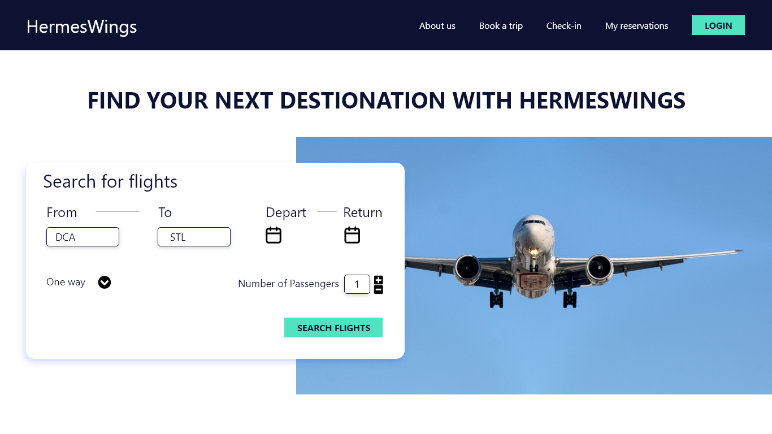

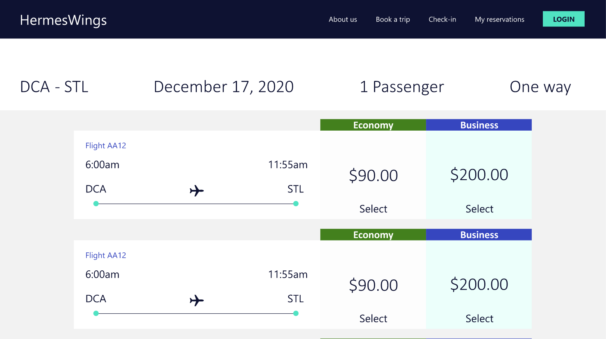

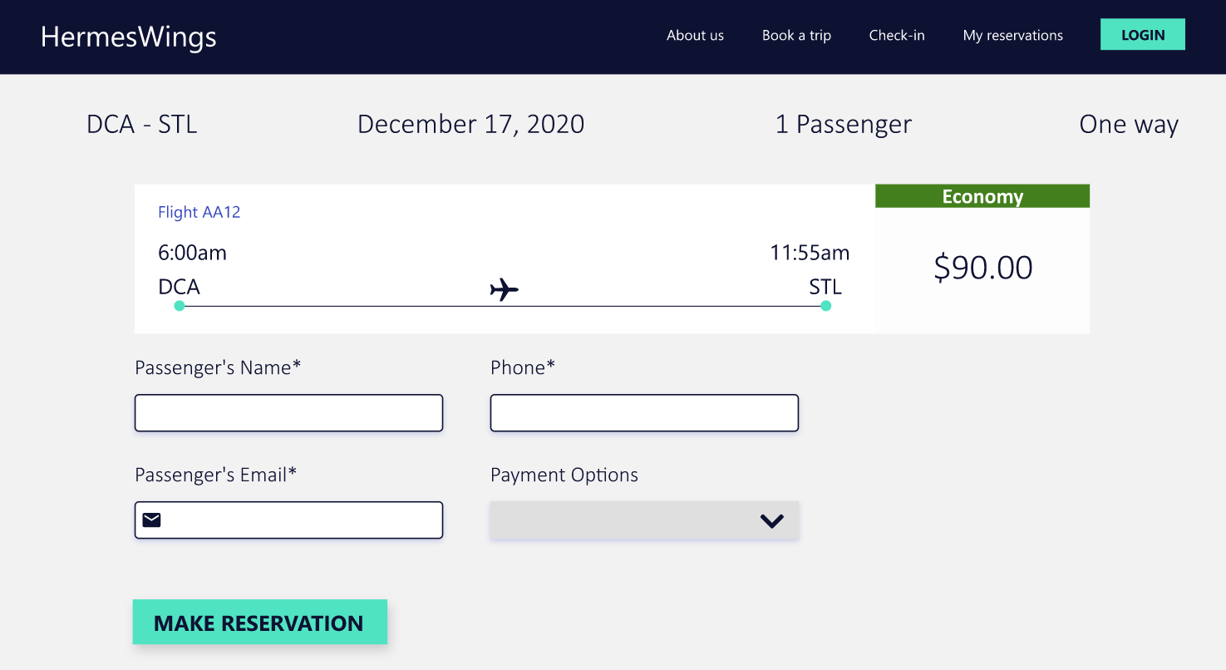

**

# **Project Challenges**

The teamwork has been a smooth process, and everybody got involved in it. It has been a great experience and the results of it are great. We have identified 3 main challenges:

* Covid-19 situation
* Lost of one team member
* Fully online coordination and meetings

# **Queries:**

**#1)Travelers name who is traveling on specific flight and date  and  reserved**

**select t.`FULL_NAME`from travelers t, reservations r, flight f where**

**f.`FLIGHT_NUMBER`='AA12' and**

**t.`TRAVELER_ID`=r.`TRAVELER_ID` and**

**r.`FLIGHT_NUMBER`=f.`FLIGHT_NUMBER`and**

**f.`DATE`='2020-11-06 20:27:07' and**

**r.`FLIGHT_DATE`= f.`DATE`;**

**select f.`FLIGHT_NUMBER`,r.`RESERVATION_ID` from reservations r join flight f on r.`FLIGHT_NUMBER`=f.`FLIGHT_NUMBER` where**

**f.FLIGHT_NUMBER='AA12' and**

**f.`DATE`='2020-11-06 20:27:07';**

**#2) List of flight  names  departing from MSP airport**

**select a.`AIRPORT_NAME`, f.`FLIGHT_NUMBER`,f.`DATE` from flight f,airport a, route r where**

**f.`ROUTE_CODE`=r.`ROUTE_CODE`and**

**a.`AIRPORT_CODE`= r.`DEPATURE_AIR_CODE`and**

**a.`AIRPORT_CODE`='MSP';**

**#3)Select crews names of  flight AA12   flying on date 2020-11-06 20:27:07**

**select c.`NAME`,f1.`CREW_ID`,c.`TYPE`,r.`DEPATURE_AIR_CODE`,f.`FLIGHT_NUMBER`,f.`DATE` from crew c,route r, flight f join flight_assignment f1 on f1.`FLIGHT_NUMBER`=f.`FLIGHT_NUMBER` where**

**f.`FLIGHT_NUMBER`='AA12' and**

**f1.`CREW_ID`=c.`CREW_ID`and**

**r.`ROUTE_CODE`=f.`ROUTE_CODE` and**

**f.`DATE`=f1.`FLIGHT_DATE`and**

**f.`DATE`='2020-11-06 20:27:07';**

**#4) List of operator names flying with flight AA12**

**select o.`NAME`,o.`TYPE`,f.`DATE` from operations_staff o JOIN flight f on o.`FLIGHT_NUMBER`=f.`FLIGHT_NUMBER`**

**where f.`FLIGHT_NUMBER`='AA12' and f.`DATE`=o.`FLIGHT_DATE`;**

**#5)List of all passenger names who is traveling flight AA21 on date 2020-11-08 20:31:05**

**select t.`FULL_NAME` from tickets_issued t join flight f on f.`FLIGHT_NUMBER`=t.`FLIGHT_NUMBER` where**

**f.`FLIGHT_NUMBER`='AA21' and t.`RESERVATION_ID` is NULL and f.`DATE`='2020-11-08 20:31:05' and f.`DATE`=t.FLIGHT_DATE**

**union all**

**select t.`FULL_NAME` from travelers t, reservations r,flight f where**

**f.`FLIGHT_NUMBER`='AA21' and**

**t.`TRAVELER_ID`=r.`TRAVELER_ID` and**

**r.`FLIGHT_NUMBER`=f.`FLIGHT_NUMBER`and**

**r.`FLIGHT_DATE`=f.`DATE` and**

**f.`DATE`='2020-11-08 20:31:05';**

**#6) List of flights flying on 2020-11-08 departing from LAX**

**select f.`FLIGHT_NUMBER`,F.DATE,R.`DEPATURE_AIR_CODE`,R.`ARRIVAL_AIR_CODE` from flight f JOIN route r ON R.`ROUTE_CODE`=F.`ROUTE_CODE` where**

**DATE(f.`DATE`) ='2020-11-08' AND**

**R.`DEPATURE_AIR_CODE`='LAX';**

**#7)Average Price paid by the travelers to fly on flight AA21**

**select avg(t.price) from tickets_issued t where t.`FLIGHT_NUMBER`='AA21' GROUP BY t.flight_number;**

**#8).Total income from the flight  AA12 on 2020-11-06**

**select sum(t.price) from tickets_issued t where**

**t.`FLIGHT_NUMBER` = 'AA12' and DATE(t.`FLIGHT_DATE`)='2020-11-06'**

**GROUP BY t.FLIGHT_NUMBER;**

**#9). Traveler history of traveler  with traveler_id as 1**

**select t.`FULL_NAME`,t.`EMAIL`,t.`PHONE`,r.FLIGHT_DATE,r.`FLIGHT_NUMBER` from travelers t join reservations r**

**on r.`TRAVELER_ID`=t.`TRAVELER_ID` where t.`TRAVELER_ID`=1;**

**#10). Update number of seats for flight AA21**

**update flight set `NUMBER_PASSENGERS`= 60 where `FLIGHT_NUMBER`='AA21';**

# **Queries Output Screenshots:**

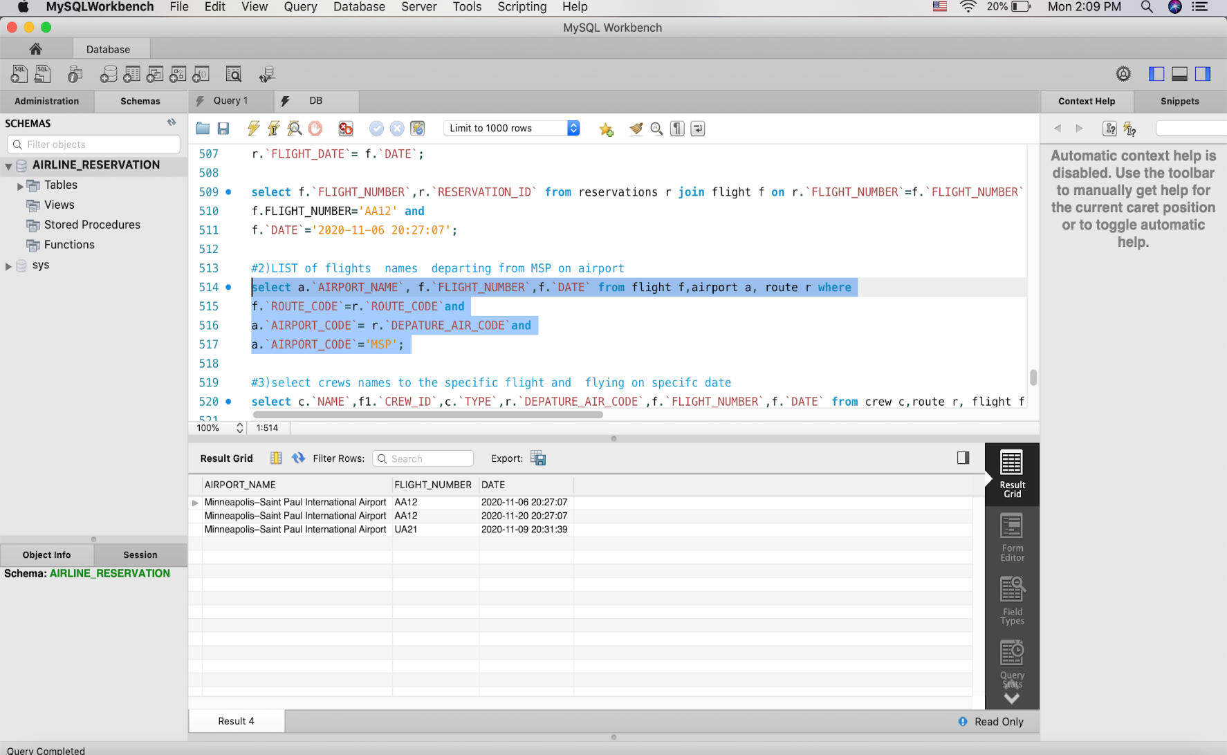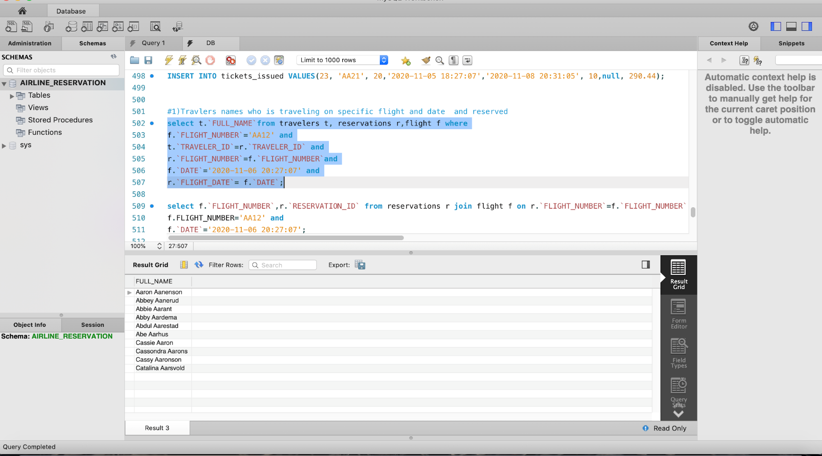

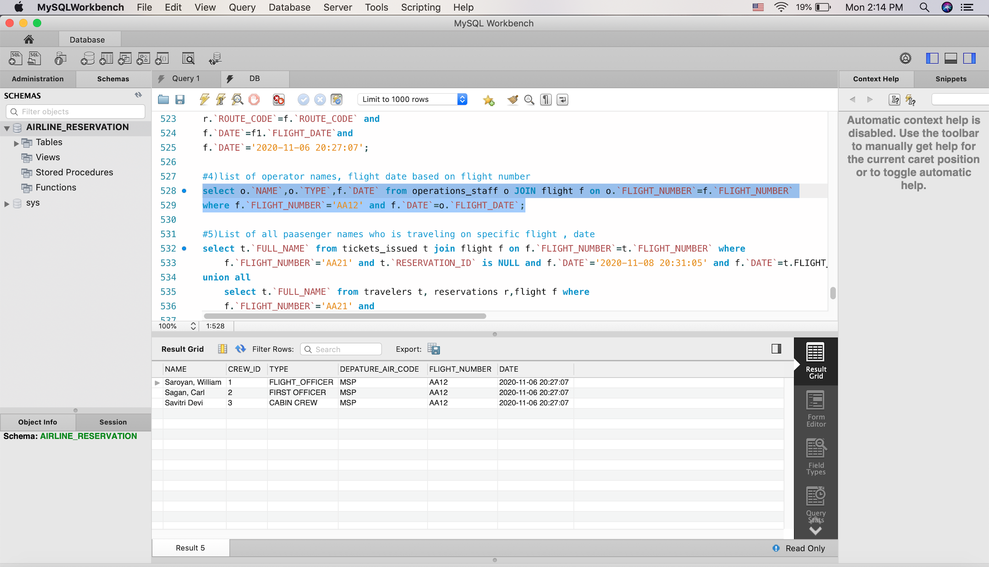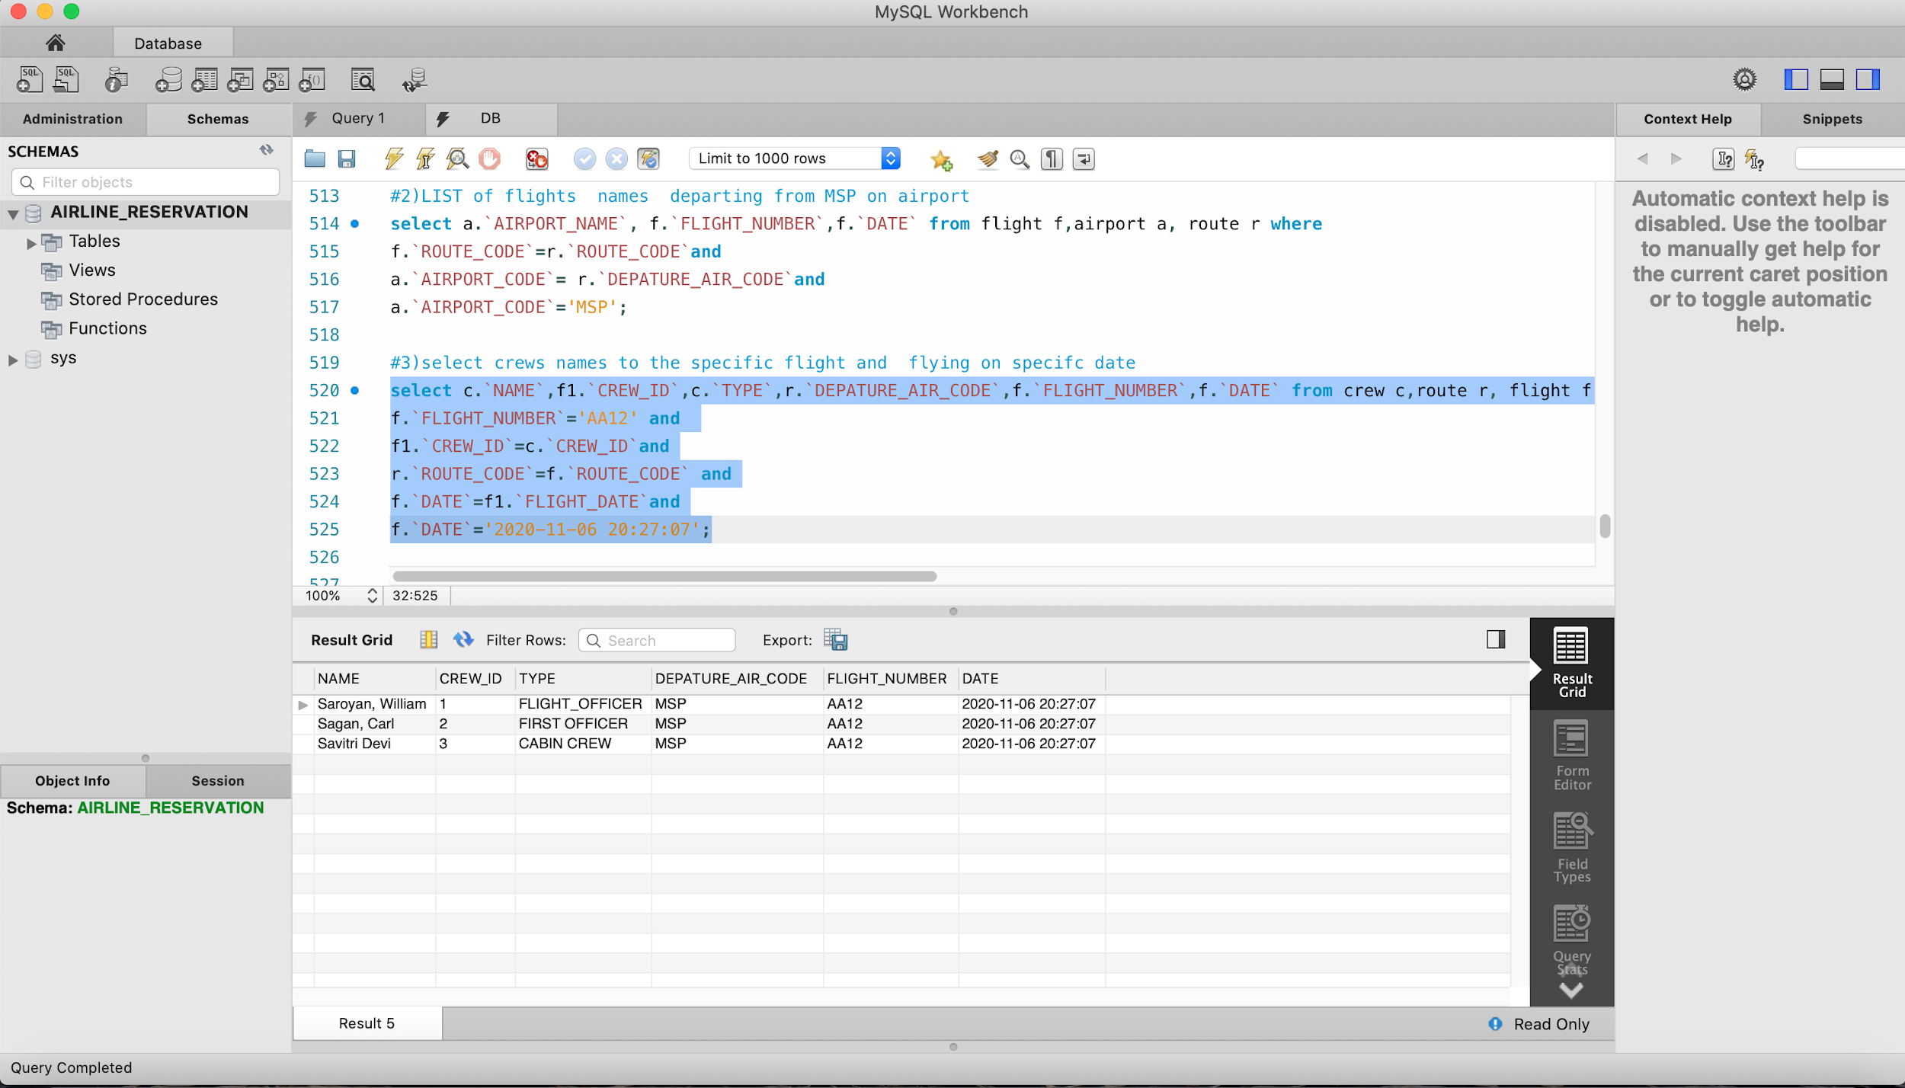

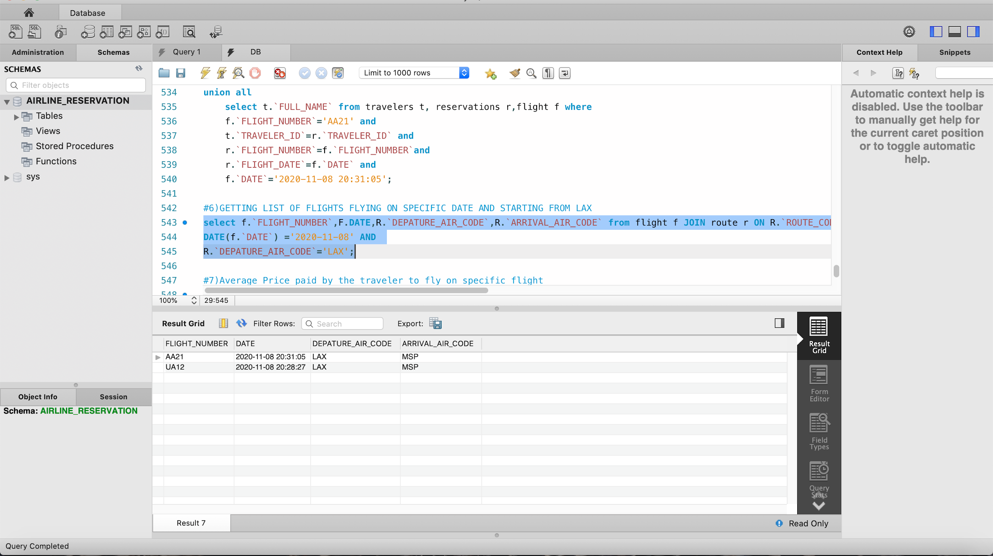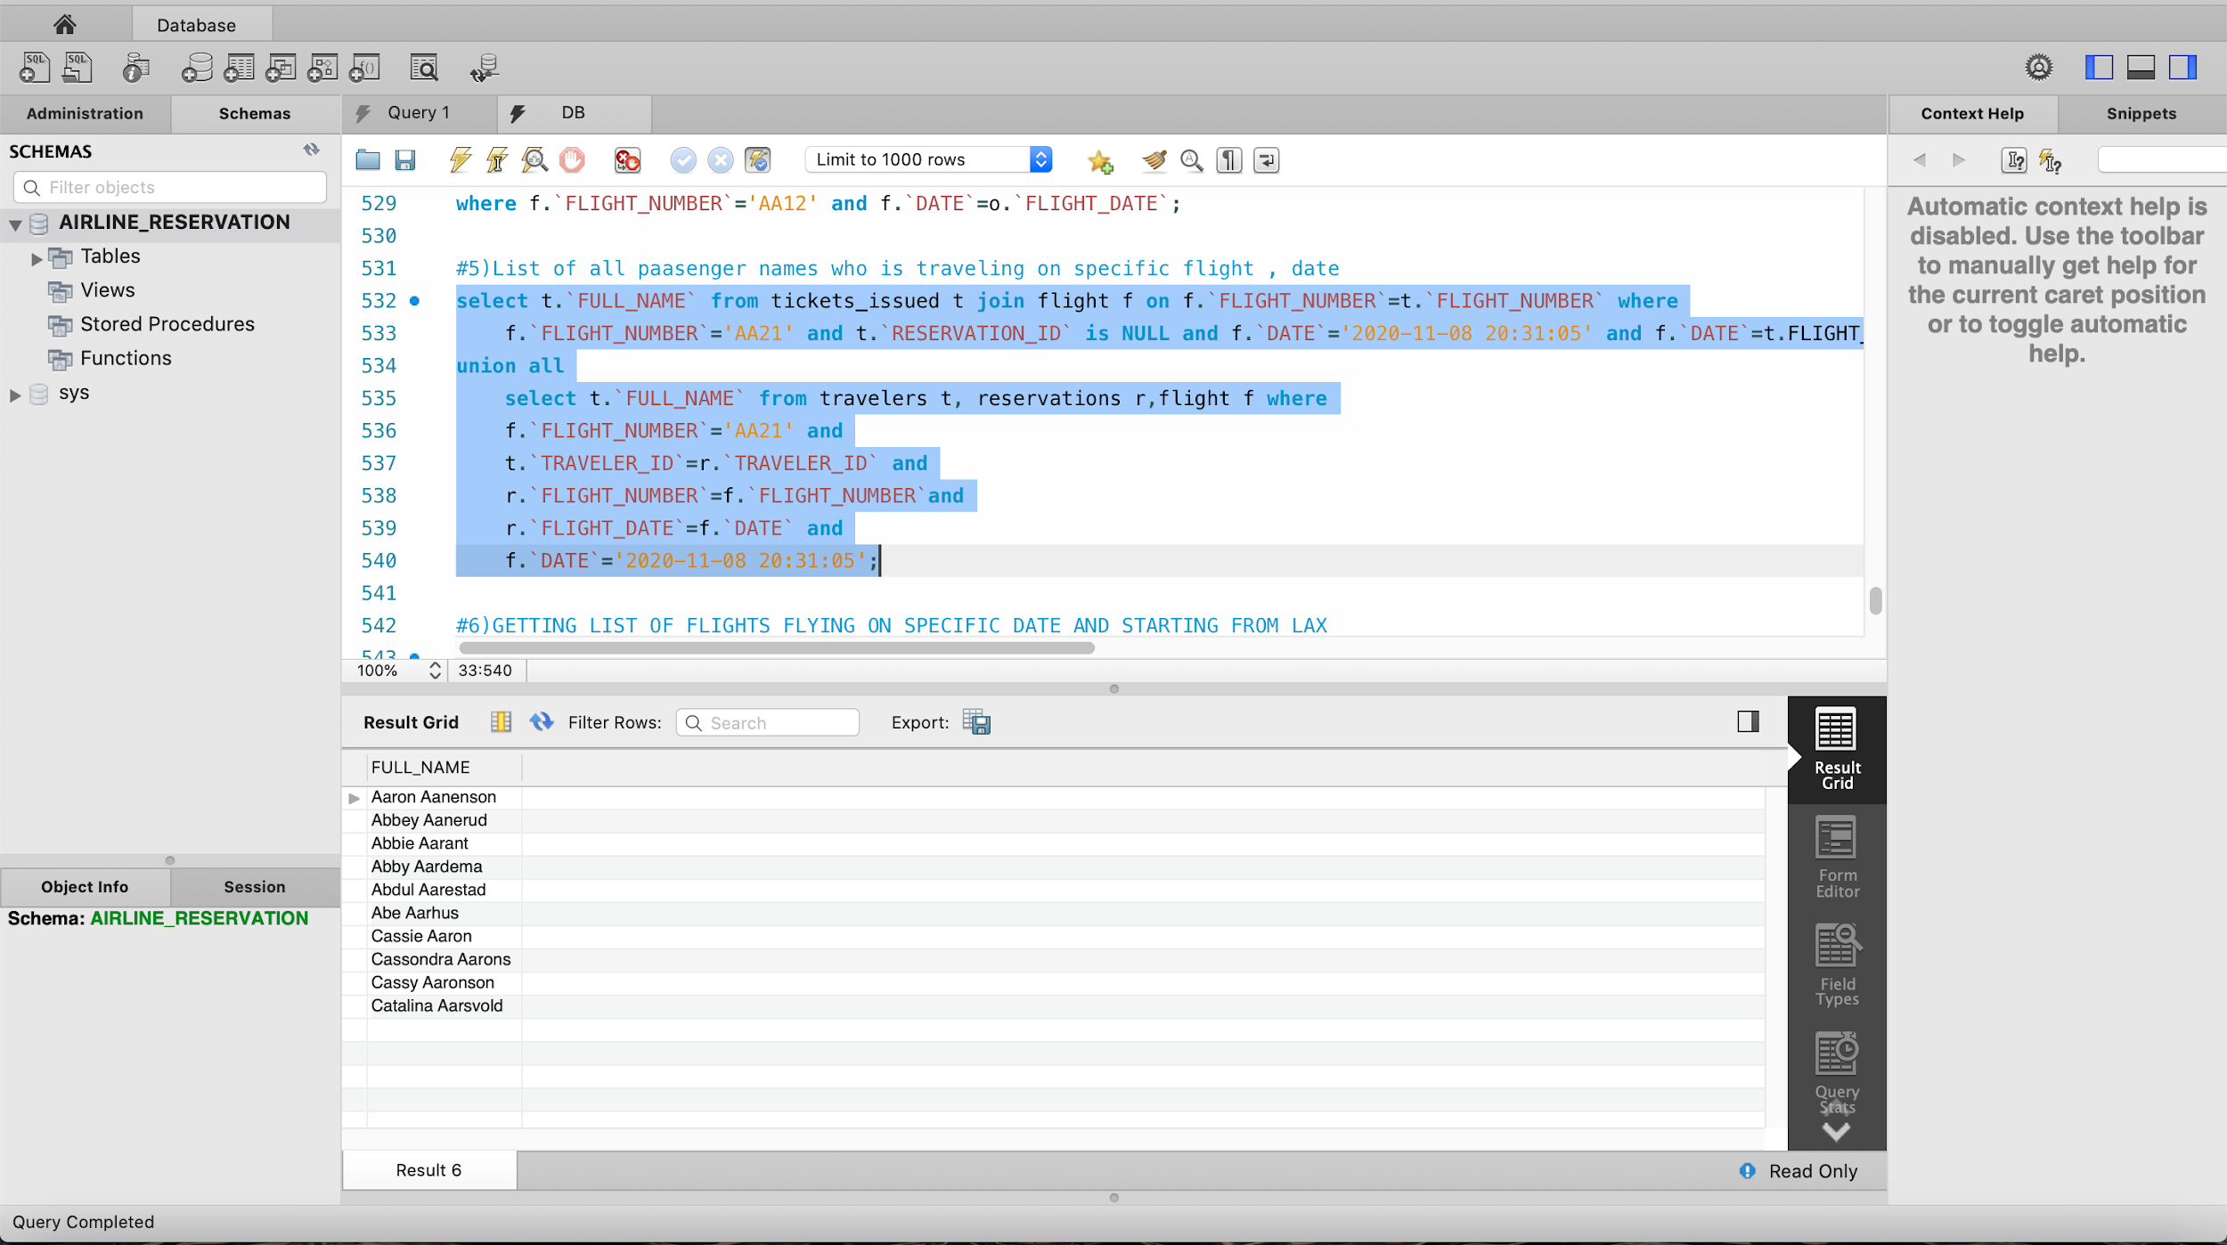

# 

# **Appendix (script):**

**CREATE TABLE  airplanes  (**

**AIRPLANE_ID  int(10) NOT NULL,**

**BRAND  varchar(20) NOT NULL,**

**MODEL  varchar(20) NOT NULL,**

**YEAR_MADE  varchar(20) DEFAULT NULL,**

**YEAR_AQUIRED  int(4) DEFAULT NULL,**

**PRIMARY KEY ( AIRPLANE_ID )**

**);**

**/*Data for the table  airplanes  */**

**insert  into  airplanes ( AIRPLANE_ID , BRAND , MODEL , YEAR_MADE , YEAR_AQUIRED ) values (1, 'Aerospatiale' , 'N262' , 2009 ,2001);**

**insert  into  airplanes ( AIRPLANE_ID , BRAND , MODEL , YEAR_MADE , YEAR_AQUIRED ) values (2, 'Airbus' , 'A310' , 2007 ,2008);**

**insert  into  airplanes ( AIRPLANE_ID , BRAND , MODEL , YEAR_MADE , YEAR_AQUIRED ) values (3, 'Airbus' , 'A318' , 2004 ,2006);**

**insert  into  airplanes ( AIRPLANE_ID , BRAND , MODEL , YEAR_MADE , YEAR_AQUIRED ) values (4, 'Airbus' , 'A319' , 2009 ,2011);**

**insert  into  airplanes ( AIRPLANE_ID , BRAND , MODEL , YEAR_MADE , YEAR_AQUIRED ) values (5, 'Airbus' , 'A19N' , 2014 ,2015);**

**insert  into  airplanes ( AIRPLANE_ID , BRAND , MODEL , YEAR_MADE , YEAR_AQUIRED ) values (6, 'Airbus' , 'A320' , 1992 ,1994);**

**insert  into  airplanes ( AIRPLANE_ID , BRAND , MODEL , YEAR_MADE , YEAR_AQUIRED ) values (7, 'Airbus' , 'A20N' , 1995 ,1996);**

**insert  into  airplanes ( AIRPLANE_ID , BRAND , MODEL , YEAR_MADE , YEAR_AQUIRED ) values (8, 'Airbus' , 'A321' , 2000 ,2003);**

**insert  into  airplanes ( AIRPLANE_ID , BRAND , MODEL , YEAR_MADE , YEAR_AQUIRED ) values (9, 'Airbus' , 'A21N' , 2005 ,2007);**

**insert  into  airplanes ( AIRPLANE_ID , BRAND , MODEL , YEAR_MADE , YEAR_AQUIRED ) values (10, 'Boeing' , '707' , 2007 ,2008);**

**insert  into  airplanes ( AIRPLANE_ID , BRAND , MODEL , YEAR_MADE , YEAR_AQUIRED ) values (11, 'Boeing' , '717' , 2004 ,2006);**

**insert  into  airplanes ( AIRPLANE_ID , BRAND , MODEL , YEAR_MADE , YEAR_AQUIRED ) values (12, 'Boeing' , '720B' , 2009 ,2011);**

**insert  into  airplanes ( AIRPLANE_ID , BRAND , MODEL , YEAR_MADE , YEAR_AQUIRED ) values (13, 'Boeing' , '727' , 2014 ,2015);**

**insert  into  airplanes ( AIRPLANE_ID , BRAND , MODEL , YEAR_MADE , YEAR_AQUIRED ) values (14, 'Boeing' , '737' , 1995 ,1996);**

**insert  into  airplanes ( AIRPLANE_ID , BRAND , MODEL , YEAR_MADE , YEAR_AQUIRED ) values (15, 'British Aerospace' , 'JS31' , 2000 ,2003);**

**insert  into  airplanes ( AIRPLANE_ID , BRAND , MODEL , YEAR_MADE , YEAR_AQUIRED ) values (16, 'British Aerospace' , 'JS32' , 2005 ,2007);**

**insert  into  airplanes ( AIRPLANE_ID , BRAND , MODEL , YEAR_MADE , YEAR_AQUIRED ) values (17, 'British Aerospace' , 'JS41' , 2007 ,2008);**

**insert  into  airplanes ( AIRPLANE_ID , BRAND , MODEL , YEAR_MADE , YEAR_AQUIRED ) values (18, 'McDonnell Douglas' , 'MD-11' , 2004 ,2006);**

**insert  into  airplanes ( AIRPLANE_ID , BRAND , MODEL , YEAR_MADE , YEAR_AQUIRED ) values (19, 'McDonnell Douglas' , 'MD-81' , 2010 ,2013);**

**insert  into  airplanes ( AIRPLANE_ID , BRAND , MODEL , YEAR_MADE , YEAR_AQUIRED ) values (20, 'McDonnell Douglas' , 'MD-82' , 2018 ,2019);**

**/*Table structure for table  airport  */**

**CREATE TABLE  airport  (**

**AIRPORT_CODE  varchar(5) NOT NULL,**

**AIRPORT_NAME  varchar(100) NOT NULL,**

**CITY varchar(20),**

**STATE varchar(2),**

**PRIMARY KEY ( AIRPORT_CODE )**

**);**

**/*Data for the table  airport  */**

**insert  into  airport ( AIRPORT_CODE , AIRPORT_NAME ) values ( 'BOS' , 'General Edward Lawrence Logan International Airport' );**

**insert  into  airport ( AIRPORT_CODE , AIRPORT_NAME ) values ( 'BWI' , 'Baltimore–Washington International Airport');**

**insert  into  airport ( AIRPORT_CODE , AIRPORT_NAME ) values ( 'CLT' , 'Charlotte Douglas International Airport' );**

**insert  into  airport ( AIRPORT_CODE , AIRPORT_NAME ) values ( 'DCA' , 'Ronald Reagan Washington National Airport' );**

**insert  into  airport ( AIRPORT_CODE , AIRPORT_NAME ) values ( 'DEN' , 'Denver International Airport' );**

**insert  into  airport ( AIRPORT_CODE , AIRPORT_NAME ) values ( 'DFW' , 'Dallas/Fort Worth International Airport' );**

**insert  into  airport ( AIRPORT_CODE , AIRPORT_NAME ) values ( 'DTW' , 'Detroit Metropolitan Airport' );**

**insert  into  airport ( AIRPORT_CODE , AIRPORT_NAME ) values ( 'EWR' , 'Newark Liberty International Airport' );**

**insert  into  airport ( AIRPORT_CODE , AIRPORT_NAME ) values ( 'FLL' , 'Fort Lauderdale–Hollywood International Airport' );**

**insert  into  airport ( AIRPORT_CODE , AIRPORT_NAME ) values ( 'HNL' , 'Daniel K. Inouye International Airport');**

**insert  into  airport ( AIRPORT_CODE , AIRPORT_NAME ) values ( 'IAD' , 'Washington Dulles International Airport' );**

**insert  into  airport ( AIRPORT_CODE , AIRPORT_NAME ) values ( 'IAH' , 'George Bush Intercontinental Airport' );**

**insert  into  airport ( AIRPORT_CODE , AIRPORT_NAME ) values ( 'JFK' , 'John F. Kennedy International Airport' );**

**insert  into  airport ( AIRPORT_CODE , AIRPORT_NAME ) values ( 'LAS' , 'McCarran International Airport' );**

**insert  into  airport ( AIRPORT_CODE , AIRPORT_NAME ) values ( 'LAX' , 'Los Angeles International Airport' );**

**insert  into  airport ( AIRPORT_CODE , AIRPORT_NAME ) values ( 'LGA' , 'LaGuardia Airport' );**

**insert  into  airport ( AIRPORT_CODE , AIRPORT_NAME ) values ( 'MCO' , 'Orlando International Airport' );**

**insert  into  airport ( AIRPORT_CODE , AIRPORT_NAME ) values ( 'MDW' , 'Chicago Midway International Airport' );**

**insert  into  airport ( AIRPORT_CODE , AIRPORT_NAME ) values ( 'MIA' , 'Miami International Airport' );**

**insert  into  airport ( AIRPORT_CODE , AIRPORT_NAME ) values ( 'MSP' , 'Minneapolis–Saint Paul International Airport' );**

**insert  into  airport ( AIRPORT_CODE , AIRPORT_NAME ) values ( 'ORD' , 'O\ Hare International Airport' );**

**insert  into  airport ( AIRPORT_CODE , AIRPORT_NAME ) values ( 'PDX' , 'Portland International Airport' );**

**insert  into  airport ( AIRPORT_CODE , AIRPORT_NAME ) values ( 'PHL' , 'Philadelphia International Airport' );**

**insert  into  airport ( AIRPORT_CODE , AIRPORT_NAME ) values ( 'PHX' , 'Phoenix Sky Harbor International Airport' );**

**insert  into  airport ( AIRPORT_CODE , AIRPORT_NAME ) values ( 'SAN' , 'San Diego International Airport' );**

**insert  into  airport ( AIRPORT_CODE , AIRPORT_NAME ) values ( 'SEA' , 'Seattle–Tacoma International Airport' );**

**insert  into  airport ( AIRPORT_CODE , AIRPORT_NAME ) values ( 'SFO' , 'San Francisco International Airport' );**

**insert  into  airport ( AIRPORT_CODE , AIRPORT_NAME ) values ( 'SLC' , 'Salt Lake City International Airport' );**

**insert  into  airport ( AIRPORT_CODE , AIRPORT_NAME ) values ( 'TPA' , 'Tampa International Airport' );**

**insert  into  airport ( AIRPORT_CODE , AIRPORT_NAME ) values ('ATL','Hartsfield Jackson Atlanta International Airport');**

**UPDATE airport SET CITY='Atlanta' ,STATE='GA' WHERE AIRPORT_CODE ='ATL';**

**UPDATE airport SET CITY='Boston' ,STATE='MA' WHERE AIRPORT_CODE ='BOS';**

**UPDATE airport SET CITY='Los Angeles' ,STATE='CA' WHERE AIRPORT_CODE ='LAX';**

**UPDATE airport SET CITY='Dallas' ,STATE='TX' WHERE AIRPORT_CODE ='DFW';**

**UPDATE airport SET CITY='Denver' ,STATE='CO' WHERE AIRPORT_CODE ='DEN';**

**UPDATE airport SET CITY='New York' ,STATE='NY' WHERE AIRPORT_CODE ='JFK';**

**UPDATE airport SET CITY='San Francisco' ,STATE='CA' WHERE AIRPORT_CODE ='SFO';**

**UPDATE airport SET CITY='Seattle' ,STATE='WA' WHERE AIRPORT_CODE ='SEA';**

**UPDATE airport SET CITY='Las Vegas' ,STATE='NV' WHERE AIRPORT_CODE ='LAS';**

**UPDATE airport SET CITY='Orlando' ,STATE='FL' WHERE AIRPORT_CODE ='MCO';**

**UPDATE airport SET CITY='New York' ,STATE='NJ' WHERE AIRPORT_CODE ='EWR';**

**UPDATE airport SET CITY='Phoenix' ,STATE='AZ' WHERE AIRPORT_CODE ='PHX';**

**UPDATE airport SET CITY='Chicago' ,STATE='IL' WHERE AIRPORT_CODE ='ORD';**

**UPDATE airport SET CITY='Charlotte' ,STATE='NC' WHERE AIRPORT_CODE ='CLT';**

**UPDATE airport SET CITY='Houston' ,STATE='TX' WHERE AIRPORT_CODE ='IAH';**

**UPDATE airport SET CITY='Miami' ,STATE='FL' WHERE AIRPORT_CODE ='MIA';**

**UPDATE airport SET CITY='Minneapolis' ,STATE='MN' WHERE AIRPORT_CODE ='MSP';**

**UPDATE airport SET CITY='Baltimore' ,STATE='MD' WHERE AIRPORT_CODE ='BWI';**

**UPDATE airport SET CITY='Arlington' ,STATE='VA' WHERE AIRPORT_CODE ='DCA';**

**UPDATE airport SET CITY='Detroit' ,STATE='MI' WHERE AIRPORT_CODE ='DTW';**

**UPDATE airport SET CITY='Fort Lauderdale' ,STATE='FL' WHERE AIRPORT_CODE ='FLL';**

**UPDATE airport SET CITY='Honolulu' ,STATE='HI' WHERE AIRPORT_CODE ='HNL';**

**UPDATE airport SET CITY='Dulles' ,STATE='VA' WHERE AIRPORT_CODE ='IAD';**

**UPDATE airport SET CITY='Queens' ,STATE='NY' WHERE AIRPORT_CODE ='LGA';**

**UPDATE airport SET CITY='Chicago' ,STATE='IL' WHERE AIRPORT_CODE ='MDW';**

**UPDATE airport SET CITY='Portland' ,STATE='OR' WHERE AIRPORT_CODE ='PDX';**

**UPDATE airport SET CITY='Philadelphia' ,STATE='PL' WHERE AIRPORT_CODE ='PHL';**

**UPDATE airport SET CITY='San Diego' ,STATE='CA' WHERE AIRPORT_CODE ='SAN';**

**UPDATE airport SET CITY='Salt Lake City' ,STATE='UT' WHERE AIRPORT_CODE ='SLC';**

**UPDATE airport SET CITY='Tampa' ,STATE='FL' WHERE AIRPORT_CODE ='TPA';**

**/*Table structure for table  route  */**

**CREATE TABLE  route  (**

**ROUTE_CODE  int(5) NOT NULL,**

**DEPATURE_AIR_CODE  varchar(5) NOT NULL,**

**ARRIVAL_AIR_CODE  varchar(5) NOT NULL,**

**PRIMARY KEY ( ROUTE_CODE ),**

**KEY  DEPT_AIR_CODE_FK  ( DEPATURE_AIR_CODE ),**

**KEY  ARR_AIR_CODE_FK  ( ARRIVAL_AIR_CODE ),**

**CONSTRAINT  DEPT_AIR_CODE_FK  FOREIGN KEY ( DEPATURE_AIR_CODE ) REFERENCES  airport  ( AIRPORT_CODE ),**

**CONSTRAINT  ARR_AIR_CODE_FK  FOREIGN KEY ( ARRIVAL_AIR_CODE ) REFERENCES  airport  ( AIRPORT_CODE )**

**);**

**insert  into  route values (1, 'MSP' ,'DCA' );**

**insert  into  route values (2, 'LAX' , 'MSP' );**

**insert  into  route values (3, 'ORD' , 'LAX' );**

**insert  into  route values (4, 'DFW', 'DEN' );**

**insert  into  route values (5, 'JFK' , 'SFO' );**

**insert  into  route values (6, 'SEA' , 'LAS' );**

**insert  into  route values (7, '﻿TPA' , 'ORD' );**

**insert  into  route values (8, 'MIA' , 'IAH' );**

**insert  into  route values (9, 'PHX' , 'CLT' );**

**insert  into  route  values (10, 'CLT' , 'ORD' );**

**insert  into  route  values (11, 'SFO' , 'ORD' );**

**insert  into  route  values (12, 'CLT' , 'SFO' );**

**insert  into  route  values (13, 'TPA' ,'SFO' );**

**insert  into  route  values (14, 'MCO' , 'PHX' );**

**insert  into  route  values (15, 'MIA' , '﻿ATL' );**

**insert  into  route  values (16, 'BOS' , 'PHX' );**

**insert  into  route  values (17, 'FLL' , 'PHX' );**

**insert  into  route  values (18, 'DTW' , 'BWI' );**

**insert  into  route  values (19, 'BWI' , 'TPA' );**

**insert  into  route  values (20, 'LGA' , 'BWI' );**

**/*Table structure for table  pilot  */**

**CREATE TABLE  pilot  (**

**PILOT_ID  int(10) NOT NULL,**

**PILOT_TYPE varchar(20),**

**FLIGHT_HOURS int(2),**

**NAME varchar(50) DEFAULT NULL,**

**PRIMARY KEY ( PILOT_ID )**

**);**

**/*Data for the table  pilot  */**

**insert  into  pilot ( PILOT_ID , NAME , PILOT_TYPE, FLIGHT_HOURS ) values (1, 'BOND, JAMES ANTHONY' ,'PILOT',8);**

**insert  into  pilot ( PILOT_ID , NAME ,PILOT_TYPE, FLIGHT_HOURS ) values (2, 'BOND, JAMES DALLAS' ,'PILOT',6);**

**insert  into  pilot ( PILOT_ID , NAME ,PILOT_TYPE, FLIGHT_HOURS ) values (3, 'BOND, JAMES EDWARD' ,'PILOT',7);**

**insert  into  pilot ( PILOT_ID , NAME ,PILOT_TYPE, FLIGHT_HOURS ) values (4, 'BOND, JAMES GORDON' ,'PILOT',12);**

**insert  into  pilot ( PILOT_ID , NAME ,PILOT_TYPE, FLIGHT_HOURS ) values (5, 'BOND, JAMES LAWERANC' ,'PILOT',15);**

**insert  into  pilot ( PILOT_ID , NAME ,PILOT_TYPE, FLIGHT_HOURS ) values (6, 'BOND, JAMES LESLIE' ,'PILOT',9);**

**insert  into  pilot ( PILOT_ID , NAME ,PILOT_TYPE, FLIGHT_HOURS ) values (7, 'BOND, JAMES RITTU' ,'PILOT',7);**

**insert  into  pilot ( PILOT_ID , NAME ,PILOT_TYPE , FLIGHT_HOURS) values (8, 'BOND, JAMES THOMAS' ,'PILOT',6);**

**insert  into  pilot ( PILOT_ID , NAME ,PILOT_TYPE, FLIGHT_HOURS ) values (9, 'TOM, PELSON' ,'PILOT',5);**

**insert  into  pilot ( PILOT_ID , NAME ,PILOT_TYPE , FLIGHT_HOURS) values (10, 'CHRIS, REFHJ' ,'PILOT',12);**

**insert  into  pilot ( PILOT_ID , NAME , PILOT_TYPE, FLIGHT_HOURS ) values (11, 'CO-BOND, JAMES ANTHONY' ,'CO-PILOT',8);**

**insert  into  pilot ( PILOT_ID , NAME ,PILOT_TYPE, FLIGHT_HOURS ) values (12, 'CO-BOND, JAMES DALLAS' ,'CO-PILOT',6);**

**insert  into  pilot ( PILOT_ID , NAME ,PILOT_TYPE, FLIGHT_HOURS ) values (13, 'CO-BOND, JAMES EDWARD' ,'CO-PILOT',7);**

**insert  into  pilot ( PILOT_ID , NAME ,PILOT_TYPE, FLIGHT_HOURS ) values (14, 'CO-BOND, JAMES GORDON' ,'CO-PILOT',12);**

**insert  into  pilot ( PILOT_ID , NAME ,PILOT_TYPE, FLIGHT_HOURS ) values (15, 'CO-BOND, JAMES LAWERANC' ,'CO-PILOT',15);**

**insert  into  pilot ( PILOT_ID , NAME ,PILOT_TYPE, FLIGHT_HOURS ) values (16, 'CO-BOND, JAMES LESLIE' ,'CO-PILOT',9);**

**insert  into  pilot ( PILOT_ID , NAME ,PILOT_TYPE, FLIGHT_HOURS ) values (17, 'CO-BOND, JAMES RITTU' ,'CO-PILOT',7);**

**insert  into  pilot ( PILOT_ID , NAME ,PILOT_TYPE , FLIGHT_HOURS) values (18, 'CO-BOND, JAMES THOMAS' ,'CO-PILOT',6);**

**insert  into  pilot ( PILOT_ID , NAME ,PILOT_TYPE, FLIGHT_HOURS ) values (19, 'CO-TOM, PELSON' ,'CO-PILOT',5);**

**insert  into  pilot ( PILOT_ID , NAME ,PILOT_TYPE , FLIGHT_HOURS) values (20, 'CO-CHRIS, REFHJ' ,'CO-PILOT',12);**

**/*Table structure for table  crew  */**

**CREATE TABLE  crew  (**

**CREW_ID  int(10) NOT NULL,**

**NAME  varchar(50) DEFAULT NULL,**

**TYPE  varchar(20) DEFAULT NULL,**

**PRIMARY KEY (CREW_ID)**

**);**

**/*Data for the table  crew  */**

**INSERT INTO crew VALUES(1, 'Saroyan, William', 'FLIGHT_OFFICER');**

**INSERT INTO crew VALUES(2, 'Sagan, Carl', 'FIRST OFFICER');**

**INSERT INTO crew VALUES(3, 'Savitri Devi', 'CABIN CREW');**

**INSERT INTO crew VALUES(4, 'Sawyer, Diane', 'FLIGHT_OFFICER');**

**INSERT INTO crew VALUES(5, 'Rimbaud, Arthur', 'FIRST OFFICER');**

**INSERT INTO crew VALUES(6, 'Rockne, Knute', 'CABIN CREW');**

**INSERT INTO crew VALUES(7, 'SRothschild, Baron', 'FLIGHT_OFFICER');**

**INSERT INTO crew VALUES(8, 'Rae, Pramod', 'FIRST OFFICER');**

**INSERT INTO crew VALUES(9, 'Raajan, Amitrajit', 'CABIN CREW');**

**INSERT INTO crew VALUES(10, 'Presley, Elvis', 'FLIGHT_OFFICER');**

**INSERT INTO crew VALUES(11, 'Plimpton, Martha', 'FIRST OFFICER');**

**INSERT INTO crew VALUES(12, 'Patrick, Saint', 'CABIN CREW');**

**INSERT INTO crew VALUES(13, 'Nugent, Ted', 'FLIGHT_OFFICER');**

**INSERT INTO crew VALUES(14, 'Najimy, Kathy', 'FIRST OFFICER');**

**INSERT INTO crew VALUES(15, 'Moore, Tim', 'CABIN CREW');**

**/*Table structure for table  travelers  */**

**DROP TABLE IF EXISTS  travelers ;**

**CREATE TABLE  travelers  (**

**TRAVELER_ID  int(10) NOT NULL,**

**FULL_NAME  varchar(50) NOT NULL,**

**EMAIL  varchar(50) DEFAULT NULL,**

**PHONE  varchar(20) DEFAULT NULL,**

**PRIMARY KEY ( TRAVELER_ID )**

**);**

**/*Data for the table  travelers  */**

**insert  into  travelers ( TRAVELER_ID , FULL_NAME , EMAIL , PHONE ) values (1, 'Aaron Aanenson' , 'aaanenson@gmail.com' , '900-345-0001' );**

**insert  into  travelers ( TRAVELER_ID , FULL_NAME , EMAIL , PHONE ) values (2, 'Abbey Aanerud' , 'aaanerud@gmail.com' , '900-345-0002' );**

**insert  into  travelers ( TRAVELER_ID , FULL_NAME , EMAIL , PHONE ) values (3, 'Abbie Aarant' , 'aaarant@gmail.com' , '900-345-0003' );**

**insert  into  travelers ( TRAVELER_ID , FULL_NAME , EMAIL , PHONE ) values (4, 'Abby Aardema' , 'aaardema@gmail.com' , '900-345-0004' );**

**insert  into  travelers ( TRAVELER_ID , FULL_NAME , EMAIL , PHONE ) values (5, 'Abdul Aarestad' , 'aaarestad@gmail.com' , '900-345-0005' );**

**insert  into  travelers ( TRAVELER_ID , FULL_NAME , EMAIL , PHONE ) values (6, 'Abe Aarhus' , 'aaarhus@gmail.com' , '900-345-0006' );**

**insert  into  travelers ( TRAVELER_ID , FULL_NAME , EMAIL , PHONE ) values (7, 'Cassie Aaron' , 'caaron@gmail.com' , '900-345-0007' );**

**insert  into  travelers ( TRAVELER_ID , FULL_NAME , EMAIL , PHONE ) values (8, 'Cassondra Aarons' , 'caarons@gmail.com' , '900-345-0008' );**

**insert  into  travelers ( TRAVELER_ID , FULL_NAME , EMAIL , PHONE ) values (9, 'Cassy Aaronson' , 'caaronson@gmail.com' , '900-345-0009' );**

**insert  into  travelers ( TRAVELER_ID , FULL_NAME , EMAIL , PHONE ) values (10, 'Catalina Aarsvold' , 'caarsvold@gmail.com' , '900-345-0010' );**

**insert  into  travelers ( TRAVELER_ID , FULL_NAME , EMAIL , PHONE ) values (11, 'Catarina Aas' , 'caas@gmail.com' , '900-345-0011' );**

**insert  into  travelers ( TRAVELER_ID , FULL_NAME , EMAIL , PHONE ) values (12, 'Caterina Aasby' , 'caasby@gmail.com' , '900-345-0012' );**

**insert  into  travelers ( TRAVELER_ID , FULL_NAME , EMAIL , PHONE ) values (13, 'Lesia Aase' , 'laase@gmail.com' , '900-345-0013' );**

**insert  into  travelers ( TRAVELER_ID , FULL_NAME , EMAIL , PHONE ) values (14, 'Leslee Aasen' , 'laasen@gmail.com' , '900-345-0014' );**

**insert  into  travelers ( TRAVELER_ID , FULL_NAME , EMAIL , PHONE ) values (15, 'Lesley Aavang' , 'laavang@gmail.com' , '900-345-0015' );**

**insert  into  travelers ( TRAVELER_ID , FULL_NAME , EMAIL , PHONE ) values (16, 'Lesli Abad' , 'labad@gmail.com' , '900-345-0016' );**

**insert  into  travelers ( TRAVELER_ID , FULL_NAME , EMAIL , PHONE ) values (17, 'Rex Abadi' , 'rabadi@gmail.com' , '900-345-0017' );**

**insert  into  travelers ( TRAVELER_ID , FULL_NAME , EMAIL , PHONE ) values (18, 'Rey Abadie' , 'rabadie@gmail.com' , '900-345-0018' );**

**insert  into  travelers ( TRAVELER_ID , FULL_NAME , EMAIL , PHONE ) values (19, 'Reyes Abair' , 'rabair@gmail.com' , '900-345-0019' );**

**insert  into  travelers ( TRAVELER_ID , FULL_NAME , EMAIL , PHONE ) values (20, 'Reyna Abaja' , 'rabaja@gmail.com' , '900-345-0020' );**

**insert  into  travelers ( TRAVELER_ID , FULL_NAME , EMAIL , PHONE ) values (21, 'Reynalda Abajian' , 'rabajian@gmail.com' , '900-345-0021' );**

**insert  into  travelers ( TRAVELER_ID , FULL_NAME , EMAIL , PHONE ) values (22, 'Reynaldo Abalos' , 'rabalos@gmail.com' , '900-345-0022' );**

**insert  into  travelers ( TRAVELER_ID , FULL_NAME , EMAIL , PHONE ) values (23, 'Rhea Zwolensky' , 'rzwolensky@gmail.com' , '900-345-0023' );**

**insert  into  travelers ( TRAVELER_ID , FULL_NAME , EMAIL , PHONE ) values (24, 'Rheba Zwolensky' , 'rzwolensky@gmail.com' , '900-345-0024' );**

**insert  into  travelers ( TRAVELER_ID , FULL_NAME , EMAIL , PHONE ) values (25, 'Santiago Zwolinski' , 'szwolinski@gmail.com' , '900-345-0025' );**

**insert  into  travelers ( TRAVELER_ID , FULL_NAME , EMAIL , PHONE ) values (26, 'Santina Zwolski' , 'szwolski@gmail.com' , '900-345-0026' );**

**insert  into  travelers ( TRAVELER_ID , FULL_NAME , EMAIL , PHONE ) values (27, 'Santo Zybia' , 'szybia@gmail.com' , '900-345-0027' );**

**insert  into  travelers ( TRAVELER_ID , FULL_NAME , EMAIL , PHONE ) values (28, 'Santos Zych' , 'szych@gmail.com' , '900-345-0028' );**

**insert  into  travelers ( TRAVELER_ID , FULL_NAME , EMAIL , PHONE ) values (29, 'Sara Zygmont' , 'szygmont@gmail.com' , '900-345-0029' );**

**insert  into  travelers ( TRAVELER_ID , FULL_NAME , EMAIL , PHONE ) values (30, 'Sarah Zyla' , 'szyla@gmail.com' , '900-345-0030' );**

**insert  into  travelers ( TRAVELER_ID , FULL_NAME , EMAIL , PHONE ) values (31, 'Sarai Zylka' , 'szylka@gmail.com' , '900-345-0031' );**

**insert  into  travelers ( TRAVELER_ID , FULL_NAME , EMAIL , PHONE ) values (32, 'Saran Zylstra' , 'szylstra@gmail.com' , '900-345-0032' );**

**insert  into  travelers ( TRAVELER_ID , FULL_NAME , EMAIL , PHONE ) values (33, 'Sari Zymowski' , 'szymowski@gmail.com' , '900-345-0033' );**

**insert  into  travelers ( TRAVELER_ID , FULL_NAME , EMAIL , PHONE ) values (34, 'Sarina Zynda' , 'szynda@gmail.com' , '900-345-0034' );**

**insert  into  travelers ( TRAVELER_ID , FULL_NAME , EMAIL , PHONE ) values (35, 'Sarita Zysett' , 'szysett@gmail.com' , '900-345-0035' );**

**insert  into  travelers ( TRAVELER_ID , FULL_NAME , EMAIL , PHONE ) values (36, 'Sasha Zysk' , 'szysk@gmail.com' , '900-345-0036' );**

**insert  into  travelers ( TRAVELER_ID , FULL_NAME , EMAIL , PHONE ) values (37, 'Saturnina Zyskowski' , 'szyskowski@gmail.com' , '900-345-0037' );**

**insert  into  travelers ( TRAVELER_ID , FULL_NAME , EMAIL , PHONE ) values (38,  'Zywiec' , 'zywiec@gmail.com' , '900-345-0038' );**

**/*Table structure for table  flight  */**

**CREATE TABLE  flight  (**

**FLIGHT_NUMBER  varchar(6) NOT NULL,**

**ROUTE_CODE  int(5) NOT NULL,**

**DATE  datetime NOT NULL,**

**PILOT_ID  int(20) NOT NULL,**

**BAGGAGE_CLAIM  varchar(5) DEFAULT NULL,**

**AIRPLANE_ID  int(10) NOT NULL,**

**NUMBER_CREW int(10),**

**NUMBER_PASSENGERS int(3),**

**PRIMARY KEY ( FLIGHT_NUMBER, DATE ),**

**KEY  ROUTE_CODE_FK  ( ROUTE_CODE ),**

**KEY  PILOT_CODE_FK  ( PILOT_ID ),**

**KEY  AIRPLANE_FLIGHT_ID (AIRPLANE_ID),**

**CONSTRAINT  ROUTE_CODE_FK  FOREIGN KEY ( ROUTE_CODE ) REFERENCES  route  ( ROUTE_CODE ),**

**CONSTRAINT  PILOT_CODE_FK  FOREIGN KEY ( PILOT_ID ) REFERENCES  pilot  ( PILOT_ID ),**

**CONSTRAINT  AIRPLANE_FLIGHT_ID  FOREIGN KEY ( AIRPLANE_ID ) REFERENCES  AIRPLANES  ( AIRPLANE_ID )**

**);**

**/*Data for the table  flight  */**

**insert into flight (FLIGHT_NUMBER, ROUTE_CODE, DATE, PILOT_ID, BAGGAGE_CLAIM, AIRPLANE_ID, NUMBER_CREW, NUMBER_PASSENGERS) values**

**('AA12','1','2020-11-06 20:27:07','1','Y',1,1,20);**

**insert into flight (FLIGHT_NUMBER, ROUTE_CODE, DATE, PILOT_ID, BAGGAGE_CLAIM, AIRPLANE_ID, NUMBER_CREW, NUMBER_PASSENGERS) values**

**('AA21','2','2020-11-08 20:31:05','1','Y',2,1,30);**

**insert into flight (FLIGHT_NUMBER, ROUTE_CODE, DATE, PILOT_ID, BAGGAGE_CLAIM, AIRPLANE_ID, NUMBER_CREW, NUMBER_PASSENGERS) values**

**('AA31','5','2020-11-08 20:33:03','5','Y',3,2,50);**

**insert into flight (FLIGHT_NUMBER, ROUTE_CODE, DATE, PILOT_ID, BAGGAGE_CLAIM, AIRPLANE_ID, NUMBER_CREW, NUMBER_PASSENGERS) values**

**('AA32','6','2020-11-05 20:33:41','6','N',4,2,10);**

**insert into flight (FLIGHT_NUMBER, ROUTE_CODE, DATE, PILOT_ID, BAGGAGE_CLAIM, AIRPLANE_ID, NUMBER_CREW, NUMBER_PASSENGERS) values**

**('AA56','8','2020-11-16 20:34:56','8','Y',5,3,20);**

**insert into flight (FLIGHT_NUMBER, ROUTE_CODE, DATE, PILOT_ID, BAGGAGE_CLAIM, AIRPLANE_ID, NUMBER_CREW, NUMBER_PASSENGERS) values**

**('AW12','3','2020-11-08 20:30:35','3','N',6,3,30);**

**insert into flight (FLIGHT_NUMBER, ROUTE_CODE, DATE, PILOT_ID, BAGGAGE_CLAIM, AIRPLANE_ID, NUMBER_CREW, NUMBER_PASSENGERS) values**

**('FN12','14','2020-11-08 20:32:36','4','Y',7,4,50);**

**insert into flight (FLIGHT_NUMBER, ROUTE_CODE, DATE, PILOT_ID, BAGGAGE_CLAIM, AIRPLANE_ID, NUMBER_CREW, NUMBER_PASSENGERS) values**

**('UA12','2','2020-11-08 20:28:27','2','N',8,4,60);**

**insert into flight (FLIGHT_NUMBER, ROUTE_CODE, DATE, PILOT_ID, BAGGAGE_CLAIM, AIRPLANE_ID, NUMBER_CREW, NUMBER_PASSENGERS) values**

**('UA21','1','2020-11-09 20:31:39','2','N',9,5,10);**

**insert into flight (FLIGHT_NUMBER, ROUTE_CODE, DATE, PILOT_ID, BAGGAGE_CLAIM, AIRPLANE_ID, NUMBER_CREW, NUMBER_PASSENGERS) values**

**('UA34','8','2020-11-16 01:35:28','7','Y',10,5,60);**

**insert into flight (FLIGHT_NUMBER, ROUTE_CODE, DATE, PILOT_ID, BAGGAGE_CLAIM, AIRPLANE_ID, NUMBER_CREW, NUMBER_PASSENGERS) values**

**('UA45','7','2020-11-10 20:34:13','7','N',11,1,90);**

**insert into flight (FLIGHT_NUMBER, ROUTE_CODE, DATE, PILOT_ID, BAGGAGE_CLAIM, AIRPLANE_ID, NUMBER_CREW, NUMBER_PASSENGERS) values**

**('AA12','1','2020-11-20 20:27:07','1','Y',1,1,20);**

**/*Table structure for table  operations_staff  */**

**CREATE TABLE operations_staff**

**(**

**OPERATIONS_STAFFID    INT(10) NOT NULL,**

**NAME                   VARCHAR(50),**

**TYPE                  VARCHAR(20),**

**FLIGHT_NUMBER         VARCHAR(6)NOT NULL,**

**FLIGHT_DATE           DATETIME(0) NOT NULL,**

**CONSTRAINT OPS_STAFF_FK FOREIGN KEY(FLIGHT_NUMBER, FLIGHT_DATE) REFERENCES flight (FLIGHT_NUMBER, DATE),**

**PRIMARY KEY(OPERATIONS_STAFFID)**

**);**

**/*Data for the table  operations_staff  */**

**insert  into  operations_staff ( OPERATIONS_STAFFID , NAME , TYPE, FLIGHT_NUMBER,FLIGHT_DATE) values (1, 'PETER, TING' , 'CLEAN','AA12','2020-11-06 20:27:07');**

**insert  into  operations_staff ( OPERATIONS_STAFFID , NAME , TYPE, FLIGHT_NUMBER,FLIGHT_DATE ) values (2,'JOE, BRUNO','MECHANICAL','AA12','2020-11-06 20:27:07');**

**insert  into  operations_staff ( OPERATIONS_STAFFID , NAME , TYPE, FLIGHT_NUMBER ,FLIGHT_DATE) values (3, 'DEREK, DAN' , 'AVIATION','AA12','2020-11-06 20:27:07');**

**insert  into  operations_staff ( OPERATIONS_STAFFID , NAME , TYPE, FLIGHT_NUMBER,FLIGHT_DATE) values (4, 'ADDISON, JOSEPH' , 'CLEAN','AA21','2020-11-08 20:31:05');**

**insert  into  operations_staff ( OPERATIONS_STAFFID , NAME , TYPE, FLIGHT_NUMBER ,FLIGHT_DATE) values (5, 'AFFLECK, BEN' , 'MECHANICAL','AA21','2020-11-08 20:31:05');**

**insert  into  operations_staff ( OPERATIONS_STAFFID , NAME , TYPE, FLIGHT_NUMBER ,FLIGHT_DATE) values (6, 'ABELSON, HAL' , 'AVIATION','AA21','2020-11-08 20:31:05');**

**insert  into  operations_staff ( OPERATIONS_STAFFID , NAME , TYPE, FLIGHT_NUMBER ,FLIGHT_DATE) values (7, 'ARAYA, TOM' , 'ATTENDANT','AA21','2020-11-08 20:31:05');**

**insert  into  operations_staff ( OPERATIONS_STAFFID , NAME , TYPE, FLIGHT_NUMBER ,FLIGHT_DATE) values (8, 'ARMSTRONG, NEIL' ,'CLEAN','AA31' ,'2020-11-08 20:33:03');**

**insert  into  operations_staff ( OPERATIONS_STAFFID , NAME , TYPE, FLIGHT_NUMBER ,FLIGHT_DATE) values (9, 'ARP, HANS' , 'MECHANICAL','AA31' ,'2020-11-08 20:33:03');**

**insert  into  operations_staff ( OPERATIONS_STAFFID , NAME , TYPE, FLIGHT_NUMBER ,FLIGHT_DATE) values (10, 'BERLIN, IRVING' , 'AVIATION' ,'AA31','2020-11-08 20:33:03');**

**insert  into  operations_staff ( OPERATIONS_STAFFID , NAME , TYPE, FLIGHT_NUMBER ,FLIGHT_DATE) values (11, 'BERLE, MILTON' ,'CLEAN','AA32','2020-11-05 20:33:41');**

**insert  into  operations_staff ( OPERATIONS_STAFFID , NAME , TYPE, FLIGHT_NUMBER ,FLIGHT_DATE) values (12, 'BETHEA, ERIN' , 'MECHANICAL','AA32','2020-11-05 20:33:41'  );**

**insert  into  operations_staff ( OPERATIONS_STAFFID , NAME , TYPE, FLIGHT_NUMBER ,FLIGHT_DATE) values (13, 'CONLON, FRED' , 'AVIATION','AA32','2020-11-05 20:33:41'  );**

**insert  into  operations_staff ( OPERATIONS_STAFFID , NAME , TYPE, FLIGHT_NUMBER ,FLIGHT_DATE) values (14, 'COOLIDGE, CALVIN' , 'ATTENDANT','AA32','2020-11-05 20:33:41');**

**insert  into  operations_staff ( OPERATIONS_STAFFID , NAME , TYPE, FLIGHT_NUMBER ,FLIGHT_DATE) values (15, 'DARWIN, CHARLES' , 'CLEAN','AA56','2020-11-16 20:34:56');**

**insert  into  operations_staff ( OPERATIONS_STAFFID , NAME , TYPE, FLIGHT_NUMBER ,FLIGHT_DATE) values (16, 'FORD, GERALD' , 'MECHANICAL','AA56','2020-11-16 20:34:56');**

**insert  into  operations_staff ( OPERATIONS_STAFFID , NAME , TYPE, FLIGHT_NUMBER ,FLIGHT_DATE) values (17, 'FRANKLIN, BENJAMIN' , 'AVIATION','AA56','2020-11-16 20:34:56'  );**

**insert  into  operations_staff ( OPERATIONS_STAFFID , NAME , TYPE, FLIGHT_NUMBER ,FLIGHT_DATE) values (18, 'FREDERICK II OF PRUSSIA' , 'ATTENDANT','AA56','2020-11-16 20:34:56');**

**insert  into  operations_staff ( OPERATIONS_STAFFID , NAME , TYPE, FLIGHT_NUMBER,FLIGHT_DATE) values (19, 'PETER, TING 2' , 'CLEAN','AA12','2020-11-20 20:27:07');**

**insert  into  operations_staff ( OPERATIONS_STAFFID , NAME , TYPE, FLIGHT_NUMBER,FLIGHT_DATE ) values (20,'JOE, BRUNO 2','MECHANICAL','AA12','2020-11-20 20:27:07');**

**insert  into  operations_staff ( OPERATIONS_STAFFID , NAME , TYPE, FLIGHT_NUMBER ,FLIGHT_DATE) values (21, 'DEREK, DAN 2' , 'AVIATION','AA12','2020-11-20 20:27:07');**

**/*Table structure for table  reservations  */**

**CREATE TABLE  reservations  (**

**RESERVATION_ID  int(10) NOT NULL,**

**FLIGHT_NUMBER  varchar(6) NOT NULL,**

**DATE  datetime NOT NULL,**

**FLIGHT_DATE  datetime NOT NULL,**

**TRAVELER_ID  int(10) NOT NULL,**

**PRICE DECIMAL(5,2) NOT NULL,**

**PRIMARY KEY ( RESERVATION_ID ),**

**KEY  FLIGHT_NUMBER_RESERVATION_FK  ( FLIGHT_NUMBER,FLIGHT_DATE ),**

**KEY  TRAVELER_ID_FK  ( TRAVELER_ID ),**

**CONSTRAINT  FLIGHT_NUMBER_RESERVATION_FK  FOREIGN KEY ( FLIGHT_NUMBER,FLIGHT_DATE ) REFERENCES  flight  ( FLIGHT_NUMBER,DATE ),**

**CONSTRAINT  TRAVELER_ID_FK  FOREIGN KEY ( TRAVELER_ID ) REFERENCES  travelers  ( TRAVELER_ID )**

**);**

**/*Table structure for table  tickets_issued  */**

**CREATE TABLE  tickets_issued  (**

**TICKER_NUMBER  int(10) NOT NULL,**

**FLIGHT_NUMBER  varchar(6) NOT NULL,**

**RESERVATION_ID  int(10) DEFAULT  NULL,**

**DATE  datetime NOT NULL,**

**FLIGHT_DATE  datetime NOT NULL,**

**TRAVELER_ID  int(10) DEFAULT NULL,**

**FULL_NAME varchar(100),**

**PRICE DECIMAL(5,2) NOT NULL,**

**PRIMARY KEY ( TICKER_NUMBER ),**

**KEY  FLIGHT_NUMBER_TICKET_FK  ( FLIGHT_NUMBER,FLIGHT_DATE ),**

**KEY  RESERVATION_ID_TICKET_FK  ( RESERVATION_ID ),**

**KEY  TRAVELER_ID_TICKET_FK  ( TRAVELER_ID ),**

**CONSTRAINT  FLIGHT_NUMBER_TICKET_FK  FOREIGN KEY ( FLIGHT_NUMBER ,FLIGHT_DATE) REFERENCES  flight  ( FLIGHT_NUMBER,DATE ),**

**CONSTRAINT  RESERVATION_ID_TICKET_FK  FOREIGN KEY ( RESERVATION_ID ) REFERENCES  reservations  ( RESERVATION_ID ),**

**CONSTRAINT  TRAVELER_ID_TICKET_FK  FOREIGN KEY ( TRAVELER_ID ) REFERENCES  travelers  ( TRAVELER_ID )**

**);**

**/*Table structure for table  flight_assignment  */**

**CREATE TABLE  flight_assignment  (**

**CREW_ID  int(10) NOT NULL,**

**DATE  datetime NOT NULL,**

**FLIGHT_NUMBER  varchar(6) NOT NULL,**

**FLIGHT_DATE  datetime NOT NULL,**

**PRIMARY KEY (CREW_ID, DATE, FLIGHT_NUMBER,FLIGHT_DATE),**

**KEY  FLIGHT_NUMBER_ASST_FK  ( FLIGHT_NUMBER,FLIGHT_DATE ),**

**CONSTRAINT  FLIGHT_NUMBER_ASST_FK  FOREIGN KEY ( FLIGHT_NUMBER,FLIGHT_DATE ) REFERENCES  flight  ( FLIGHT_NUMBER,DATE )**

**);**

**/*Data for the table  flight_assignment  */**

**INSERT INTO flight_assignment VALUES(1, '2020-11-06 20:27:07' , 'AA12','2020-11-06 20:27:07')  ;**

**INSERT INTO flight_assignment VALUES(2, '2020-11-06 20:27:07' , 'AA12','2020-11-06 20:27:07')  ;**

**INSERT INTO flight_assignment VALUES(3, '2020-11-06 20:27:07' , 'AA12','2020-11-06 20:27:07')  ;**

**INSERT INTO flight_assignment VALUES(4, '2020-11-08 20:31:05' , 'AA21','2020-11-08 20:31:05')  ;**

**INSERT INTO flight_assignment VALUES(5, '2020-11-08 20:31:05' , 'AA21','2020-11-08 20:31:05')  ;**

**INSERT INTO flight_assignment VALUES(6, '2020-11-08 20:31:05' , 'AA21','2020-11-08 20:31:05')  ;**

**INSERT INTO flight_assignment VALUES(7, '2020-11-08 20:33:03' , 'AA31','2020-11-08 20:33:03')  ;**

**INSERT INTO flight_assignment VALUES(8, '2020-11-08 20:33:03' , 'AA31','2020-11-08 20:33:03')  ;**

**INSERT INTO flight_assignment VALUES(9, '2020-11-08 20:33:03' , 'AA31','2020-11-08 20:33:03')  ;**

**INSERT INTO flight_assignment VALUES(1, '2020-11-20 20:27:07' , 'AA12','2020-11-20 20:27:07')  ;**

**INSERT INTO flight_assignment VALUES(2, '2020-11-20 20:27:07' , 'AA12','2020-11-20 20:27:07')  ;**

**INSERT INTO flight_assignment VALUES(3, '2020-11-20 20:27:07' , 'AA12','2020-11-20 20:27:07')  ;**

**INSERT INTO flight_assignment VALUES(4, '2020-11-09 20:31:39' , 'UA21','2020-11-09 20:31:39')  ;**

**INSERT INTO flight_assignment VALUES(5, '2020-11-09 20:31:39' , 'UA21','2020-11-09 20:31:39')  ;**

**INSERT INTO flight_assignment VALUES(6, '2020-11-09 20:31:39' , 'UA21','2020-11-09 20:31:39')  ;**

**INSERT INTO flight_assignment VALUES(7, '2020-11-16 01:35:28' , 'UA34','2020-11-16 01:35:28')  ;**

**INSERT INTO flight_assignment VALUES(8, '2020-11-16 01:35:28' , 'UA34','2020-11-16 01:35:28')  ;**

**INSERT INTO flight_assignment VALUES(9, '2020-11-16 01:35:28' , 'UA34','2020-11-16 01:35:28')  ;**

**/*Data for the table  reservations  */**

**INSERT INTO reservations VALUES(1, 'AA12', '2020-11-05 20:27:07','2020-11-06 20:27:07', 1, 230.44);**

**INSERT INTO reservations VALUES(2, 'AA12', '2020-11-03 20:27:07','2020-11-06 20:27:07', 2, 230.44);**

**INSERT INTO reservations VALUES(3, 'AA12', '2020-11-05 22:27:07','2020-11-06 20:27:07', 3, 230.44);**

**INSERT INTO reservations VALUES(4, 'AA12', '2020-11-04 20:27:07','2020-11-06 20:27:07', 4, 250.44);**

**INSERT INTO reservations VALUES(5, 'AA12', '2020-11-01 20:27:07','2020-11-06 20:27:07', 5, 230.44);**

**INSERT INTO reservations VALUES(6, 'AA12', '2020-11-04 09:27:07','2020-11-06 20:27:07', 6, 20.44);**

**INSERT INTO reservations VALUES(7, 'AA12', '2020-11-01 10:27:07','2020-11-06 20:27:07', 7, 230.44);**

**INSERT INTO reservations VALUES(8, 'AA12', '2020-10-05 20:27:07','2020-11-06 20:27:07', 8, 230.44);**

**INSERT INTO reservations VALUES(9, 'AA12', '2020-10-05 20:27:07','2020-11-06 20:27:07', 9, 20.44);**

**INSERT INTO reservations VALUES(10, 'AA12', '2020-11-05 18:27:07','2020-11-06 20:27:07', 10, 290.44);**

**INSERT INTO reservations VALUES(100, 'AA12', '2020-11-20 20:27:07','2020-11-20 20:27:07', 10, 290.44);**

**INSERT INTO reservations VALUES(11, 'AA21', '2020-11-05 20:27:07','2020-11-08 20:31:05', 1, 230.44);**

**INSERT INTO reservations VALUES(12, 'AA21', '2020-11-03 20:27:07','2020-11-08 20:31:05', 2, 230.44);**

**INSERT INTO reservations VALUES(13, 'AA21', '2020-11-05 22:27:07','2020-11-08 20:31:05', 3, 230.44);**

**INSERT INTO reservations VALUES(14, 'AA21', '2020-11-04 20:27:07','2020-11-08 20:31:05', 4, 250.44);**

**INSERT INTO reservations VALUES(15, 'AA21', '2020-11-01 20:27:07','2020-11-08 20:31:05', 5, 230.44);**

**INSERT INTO reservations VALUES(16, 'AA21', '2020-11-04 09:27:07','2020-11-08 20:31:05', 6, 20.44);**

**INSERT INTO reservations VALUES(17, 'AA21', '2020-11-01 10:27:07','2020-11-08 20:31:05', 7, 230.44);**

**INSERT INTO reservations VALUES(18, 'AA21', '2020-10-05 20:27:07','2020-11-08 20:31:05', 8, 230.44);**

**INSERT INTO reservations VALUES(19, 'AA21', '2020-10-05 20:27:07','2020-11-08 20:31:05', 9, 20.44);**

**INSERT INTO reservations VALUES(20, 'AA21', '2020-11-05 18:27:07','2020-11-08 20:31:05', 10, 290.44);**

**/*Data for the table  tickets_issued  */**

**#Booked at airport**

**INSERT INTO tickets_issued VALUES(1, 'AA12', null, '2020-11-05 20:27:07', '2020-11-06 20:27:07',null, 'Aaron Aanenson',230.44);**

**INSERT INTO tickets_issued VALUES(2, 'AA12', null, '2020-11-06 20:27:07','2020-11-20 20:27:07', null, 'Test TICKET',230.44);**

**#Online reservation  for flight1**

**INSERT INTO tickets_issued VALUES(3, 'AA12',1, '2020-11-05 20:27:07','2020-11-06 20:27:07', 1,null, 230.44);**

**INSERT INTO tickets_issued VALUES(4, 'AA12', 2,'2020-11-03 20:27:07','2020-11-06 20:27:07', 2,null, 230.44);**

**INSERT INTO tickets_issued VALUES(5, 'AA12', 3,'2020-11-05 22:27:07','2020-11-06 20:27:07', 3,null, 230.44);**

**INSERT INTO tickets_issued VALUES(6, 'AA12',4, '2020-11-04 20:27:07','2020-11-06 20:27:07', 4,null, 250.44);**

**INSERT INTO tickets_issued VALUES(7, 'AA12', 5,'2020-11-01 20:27:07','2020-11-06 20:27:07', 5,null, 230.44);**

**INSERT INTO tickets_issued VALUES(8, 'AA12',6, '2020-11-04 09:27:07','2020-11-06 20:27:07', 6, null,20.44);**

**INSERT INTO tickets_issued VALUES(9, 'AA12',7, '2020-11-01 10:27:07','2020-11-06 20:27:07', 7, null,230.44);**

**INSERT INTO tickets_issued VALUES(10, 'AA12',8, '2020-10-05 20:27:07','2020-11-06 20:27:07', 8, null,230.44);**

**INSERT INTO tickets_issued VALUES(11, 'AA12', 9,'2020-10-05 20:27:07','2020-11-06 20:27:07', 9, null,20.44);**

**INSERT INTO tickets_issued VALUES(12, 'AA12', 10,'2020-11-05 18:27:07','2020-11-06 20:27:07', 10,null, 290.44);**

**#online reservation for flight2**

**INSERT INTO tickets_issued VALUES(13, 'AA12',100, '2020-11-20 20:27:07','2020-11-20 20:27:07', 10,null, 290.44);**

**INSERT INTO tickets_issued VALUES(14, 'AA21',11, '2020-11-05 20:27:07','2020-11-08 20:31:05', 1, null,230.44);**

**INSERT INTO tickets_issued VALUES(15, 'AA21',12, '2020-11-03 20:27:07','2020-11-08 20:31:05', 2,null, 230.44);**

**INSERT INTO tickets_issued VALUES(16, 'AA21',13, '2020-11-05 22:27:07','2020-11-08 20:31:05', 3, null,230.44);**

**INSERT INTO tickets_issued VALUES(17, 'AA21', 14,'2020-11-04 20:27:07','2020-11-08 20:31:05', 4, null,250.44);**

**INSERT INTO tickets_issued VALUES(18, 'AA21', 15,'2020-11-01 20:27:07','2020-11-08 20:31:05', 5, null,230.44);**

**INSERT INTO tickets_issued VALUES(19, 'AA21', 16,'2020-11-04 09:27:07','2020-11-08 20:31:05', 6, null,20.44);**

**INSERT INTO tickets_issued VALUES(20, 'AA21', 17,'2020-11-01 10:27:07','2020-11-08 20:31:05', 7, null,230.44);**

**INSERT INTO tickets_issued VALUES(21, 'AA21',18, '2020-10-05 20:27:07','2020-11-08 20:31:05', 8, null,230.44);**

**INSERT INTO tickets_issued VALUES(22, 'AA21', 19,'2020-10-05 20:27:07','2020-11-08 20:31:05', 9, null,20.44);**

**INSERT INTO tickets_issued VALUES(23, 'AA21', 20,'2020-11-05 18:27:07','2020-11-08 20:31:05', 10,null, 290.44);**

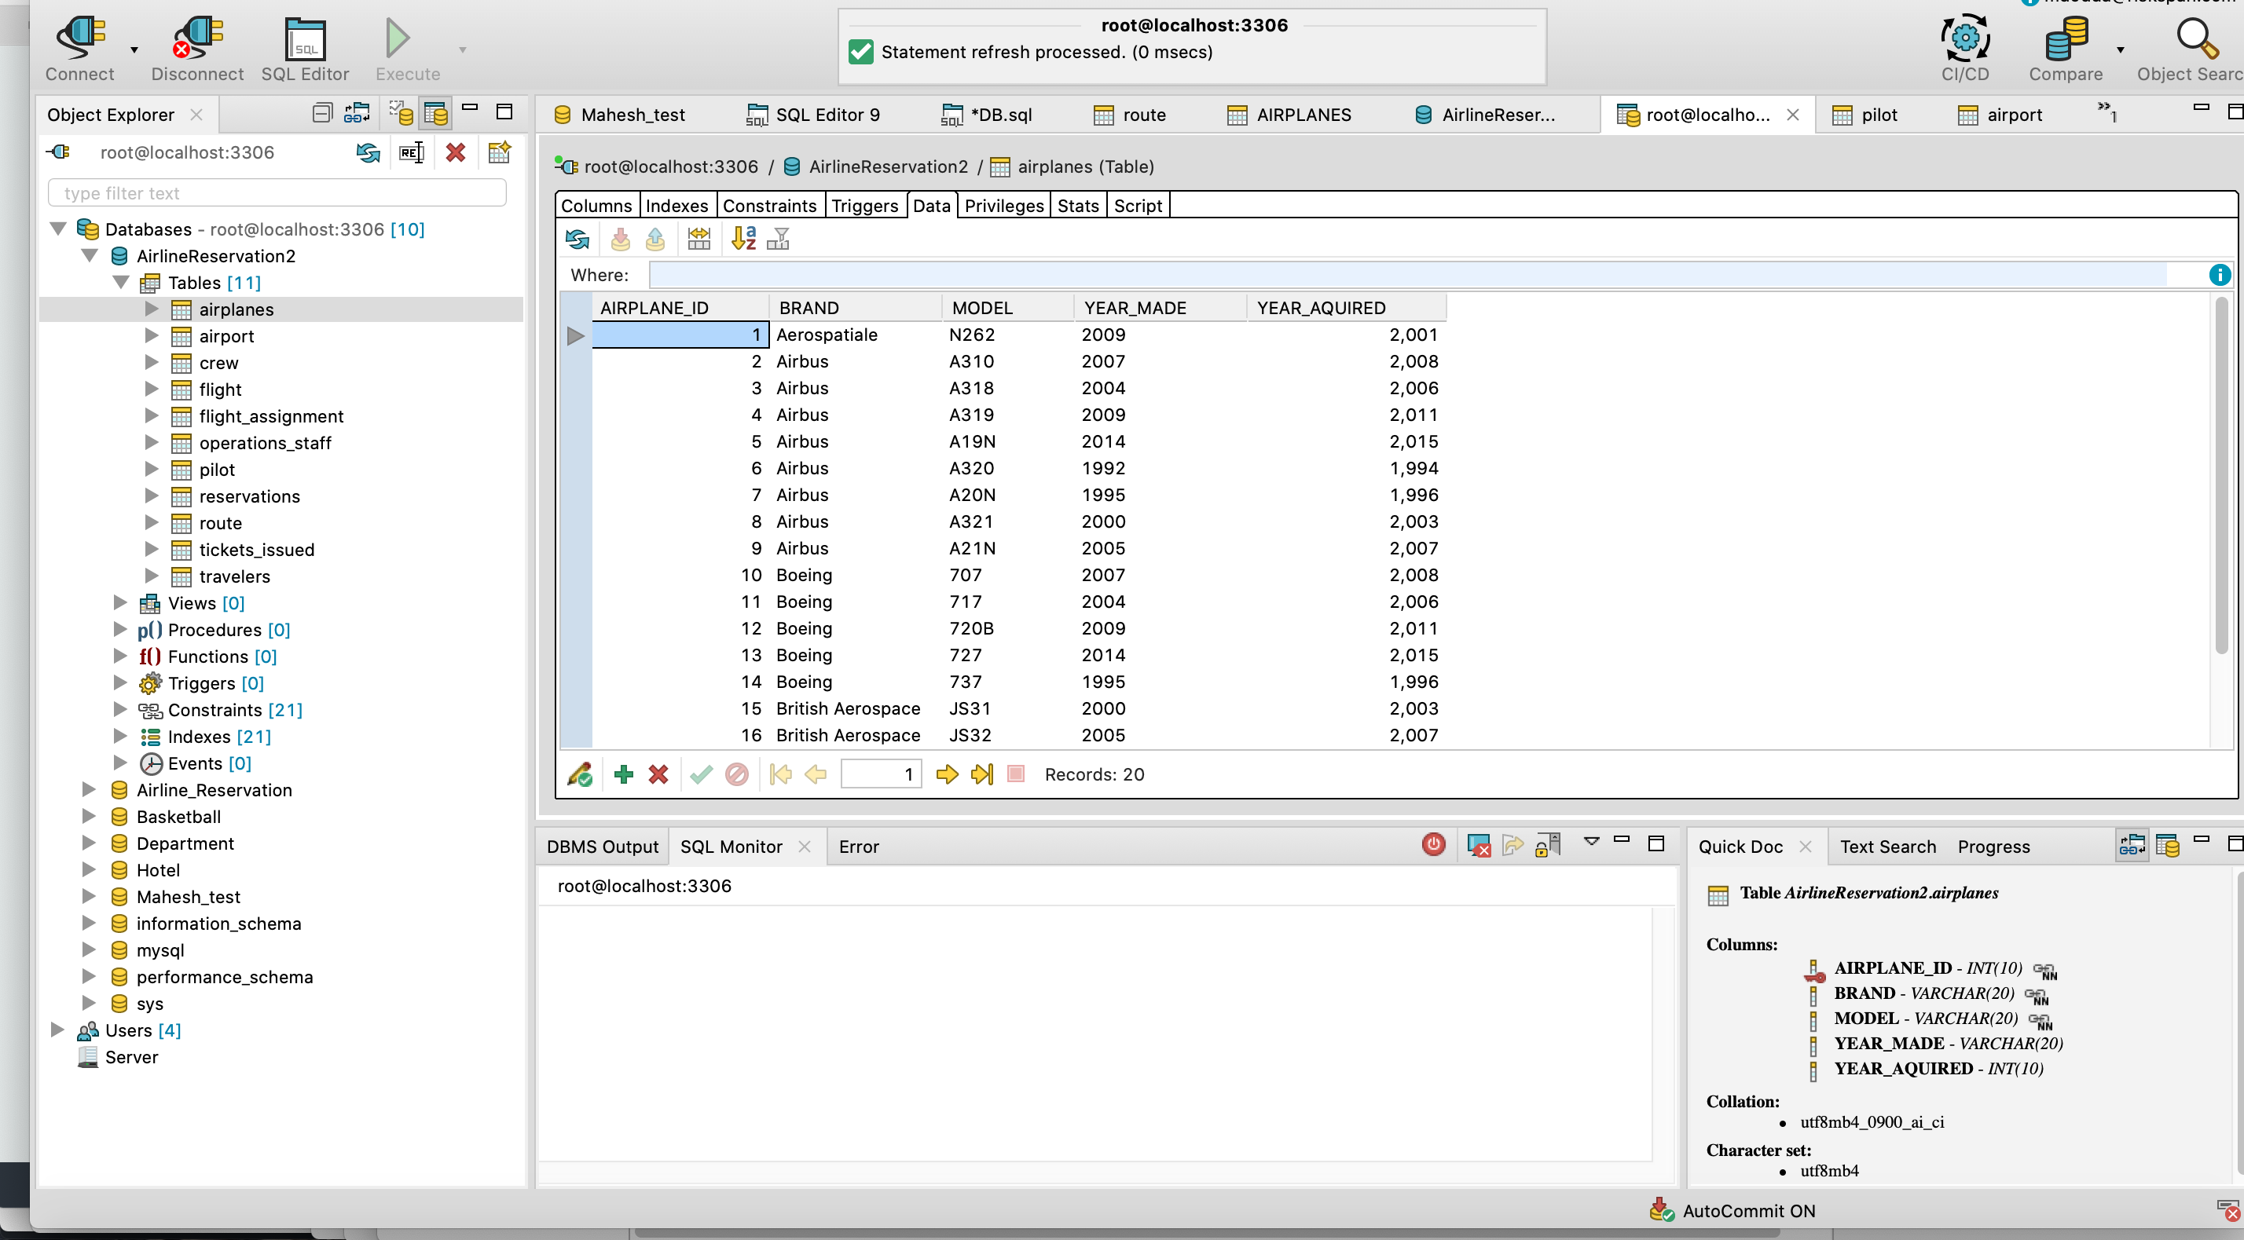

# **Screenshot:**

Airport Table Data:

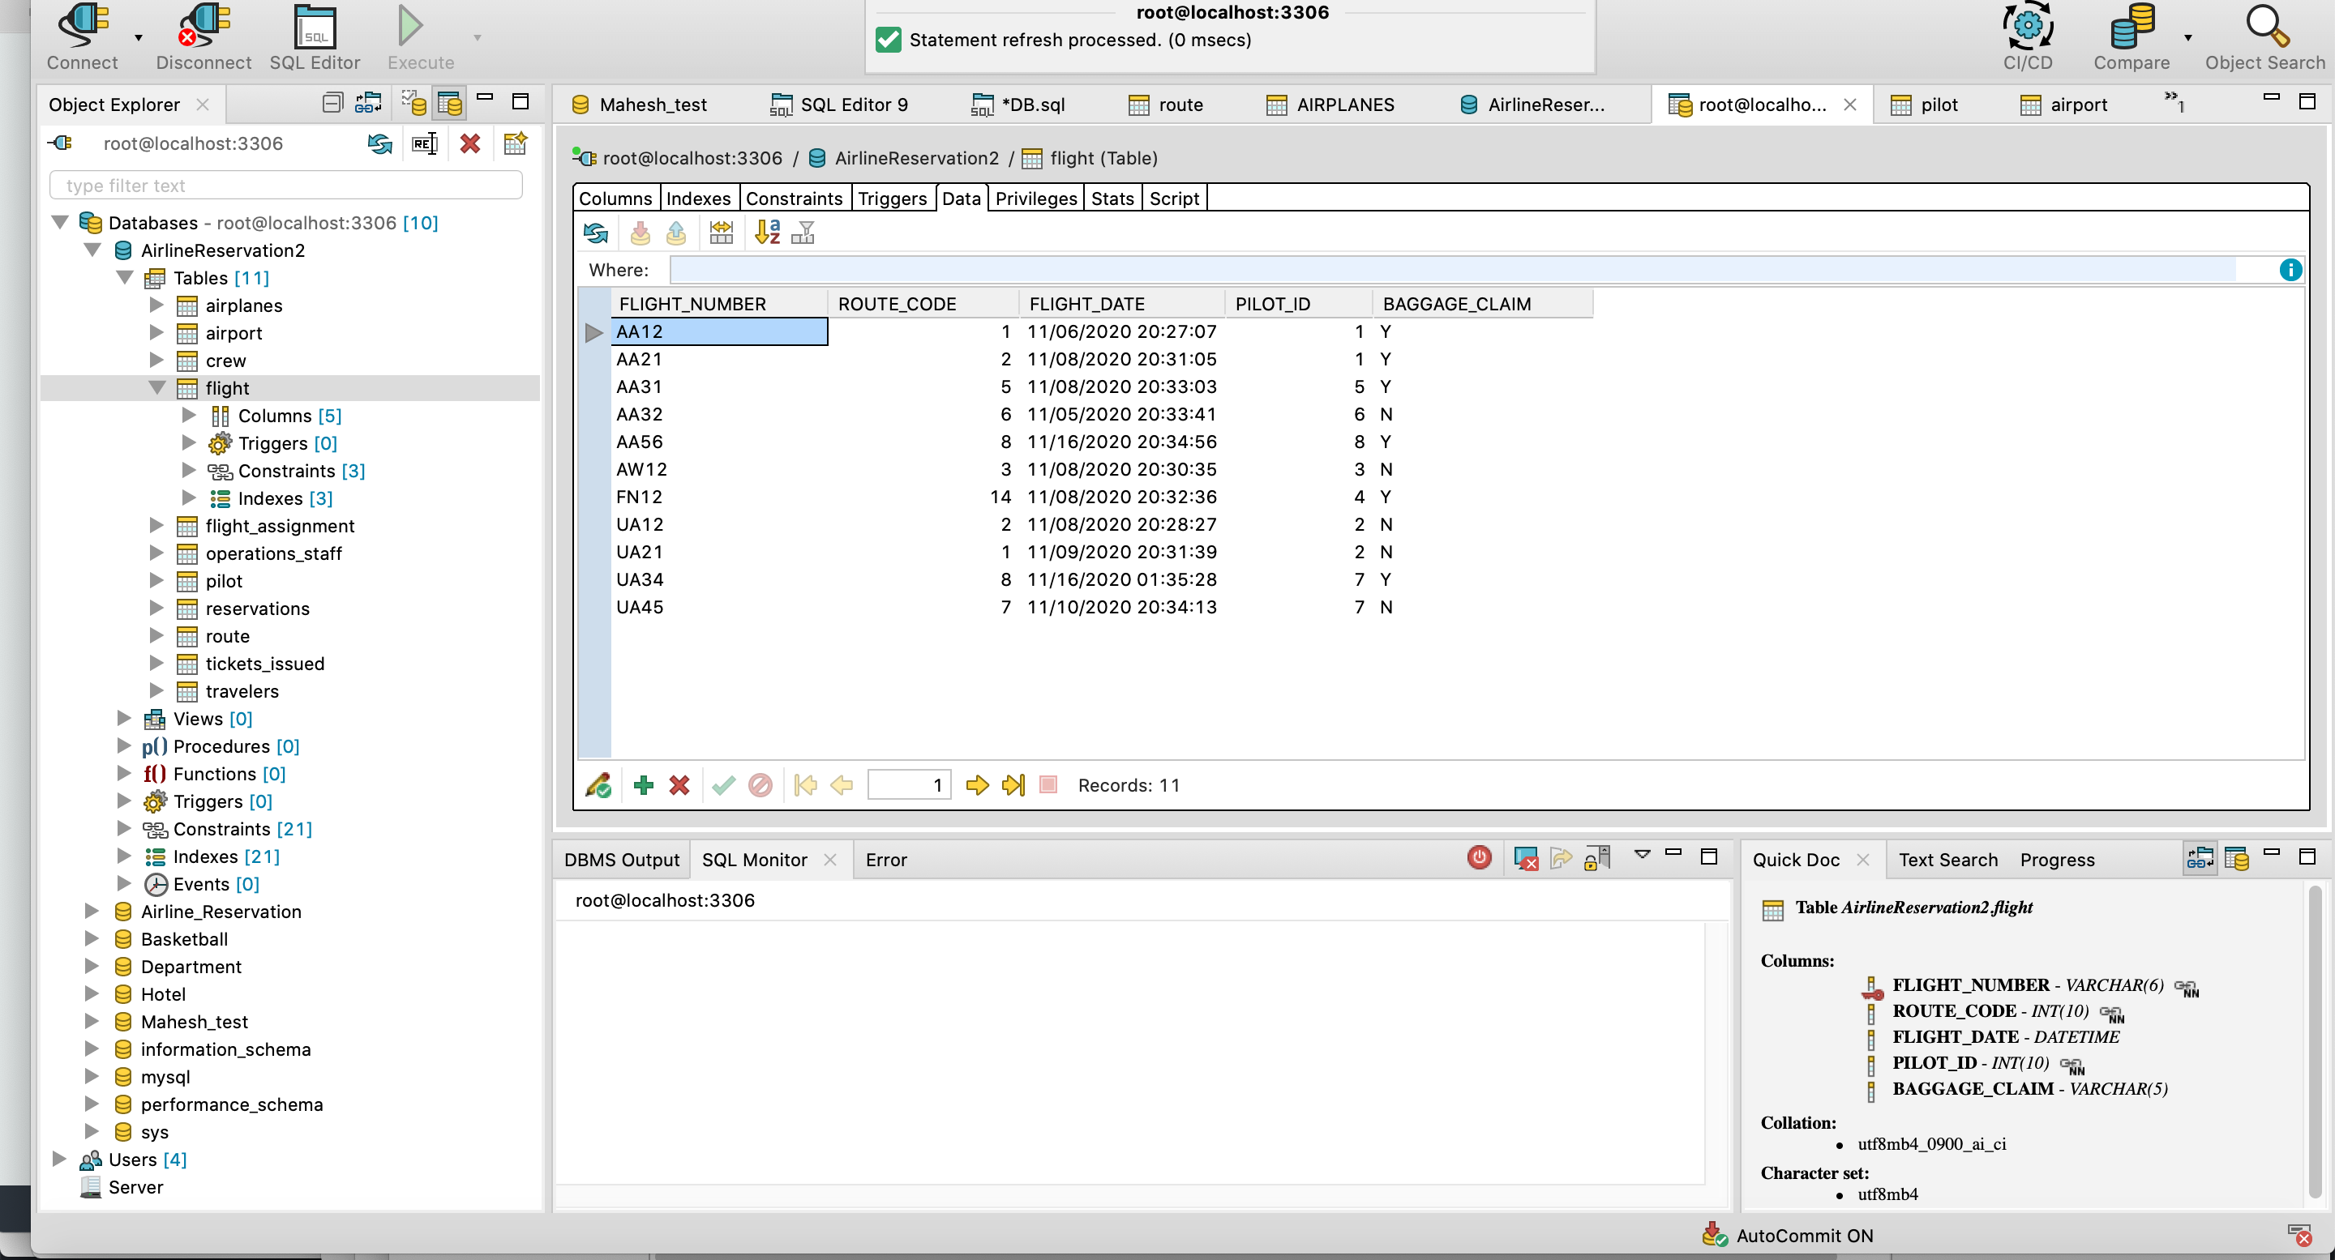Flight Table Data:

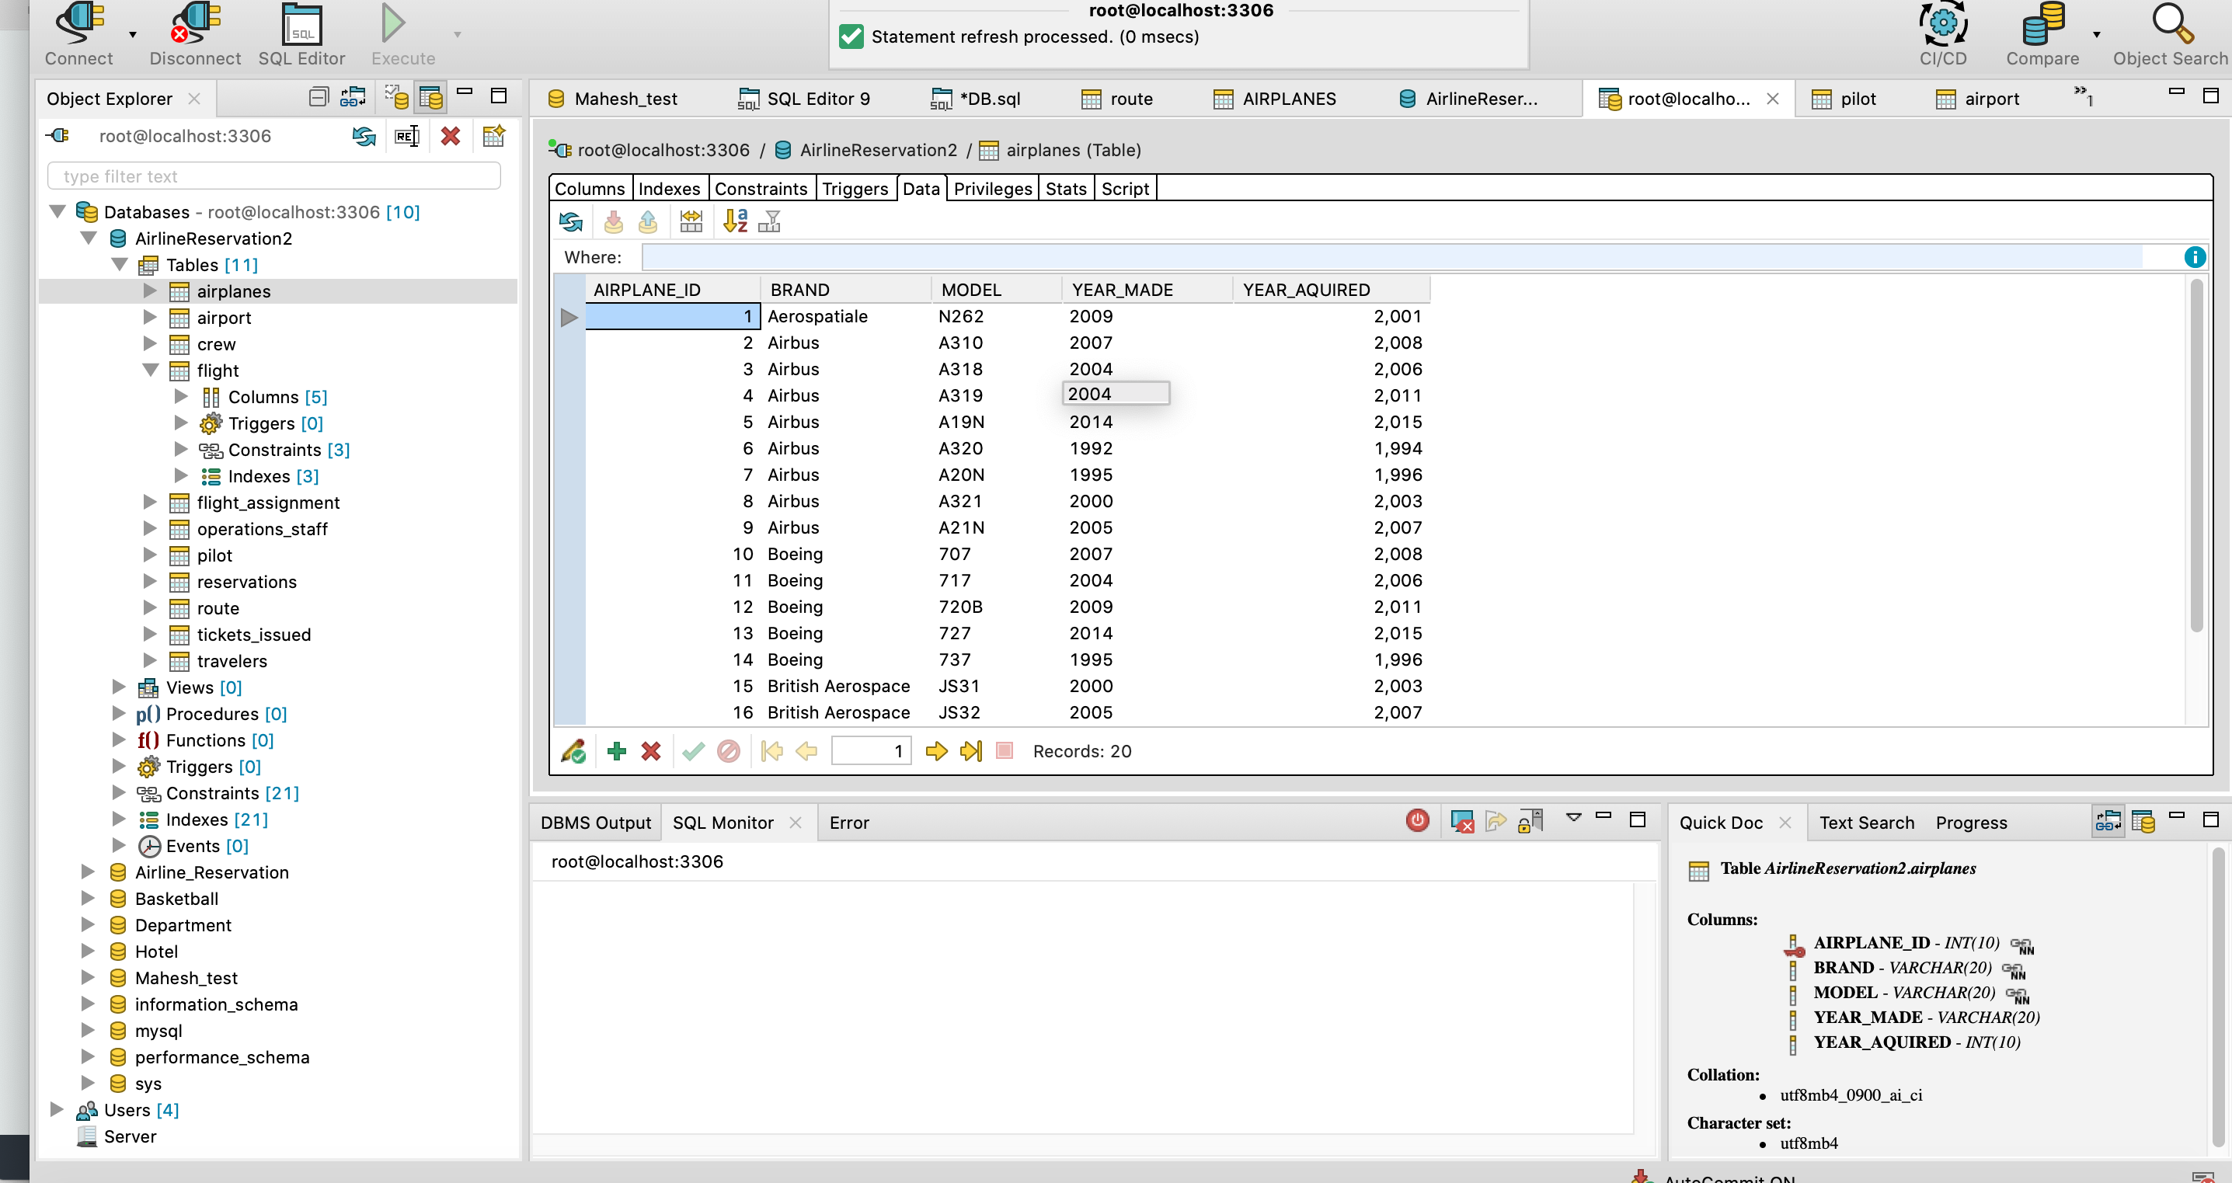Airplanes Table:

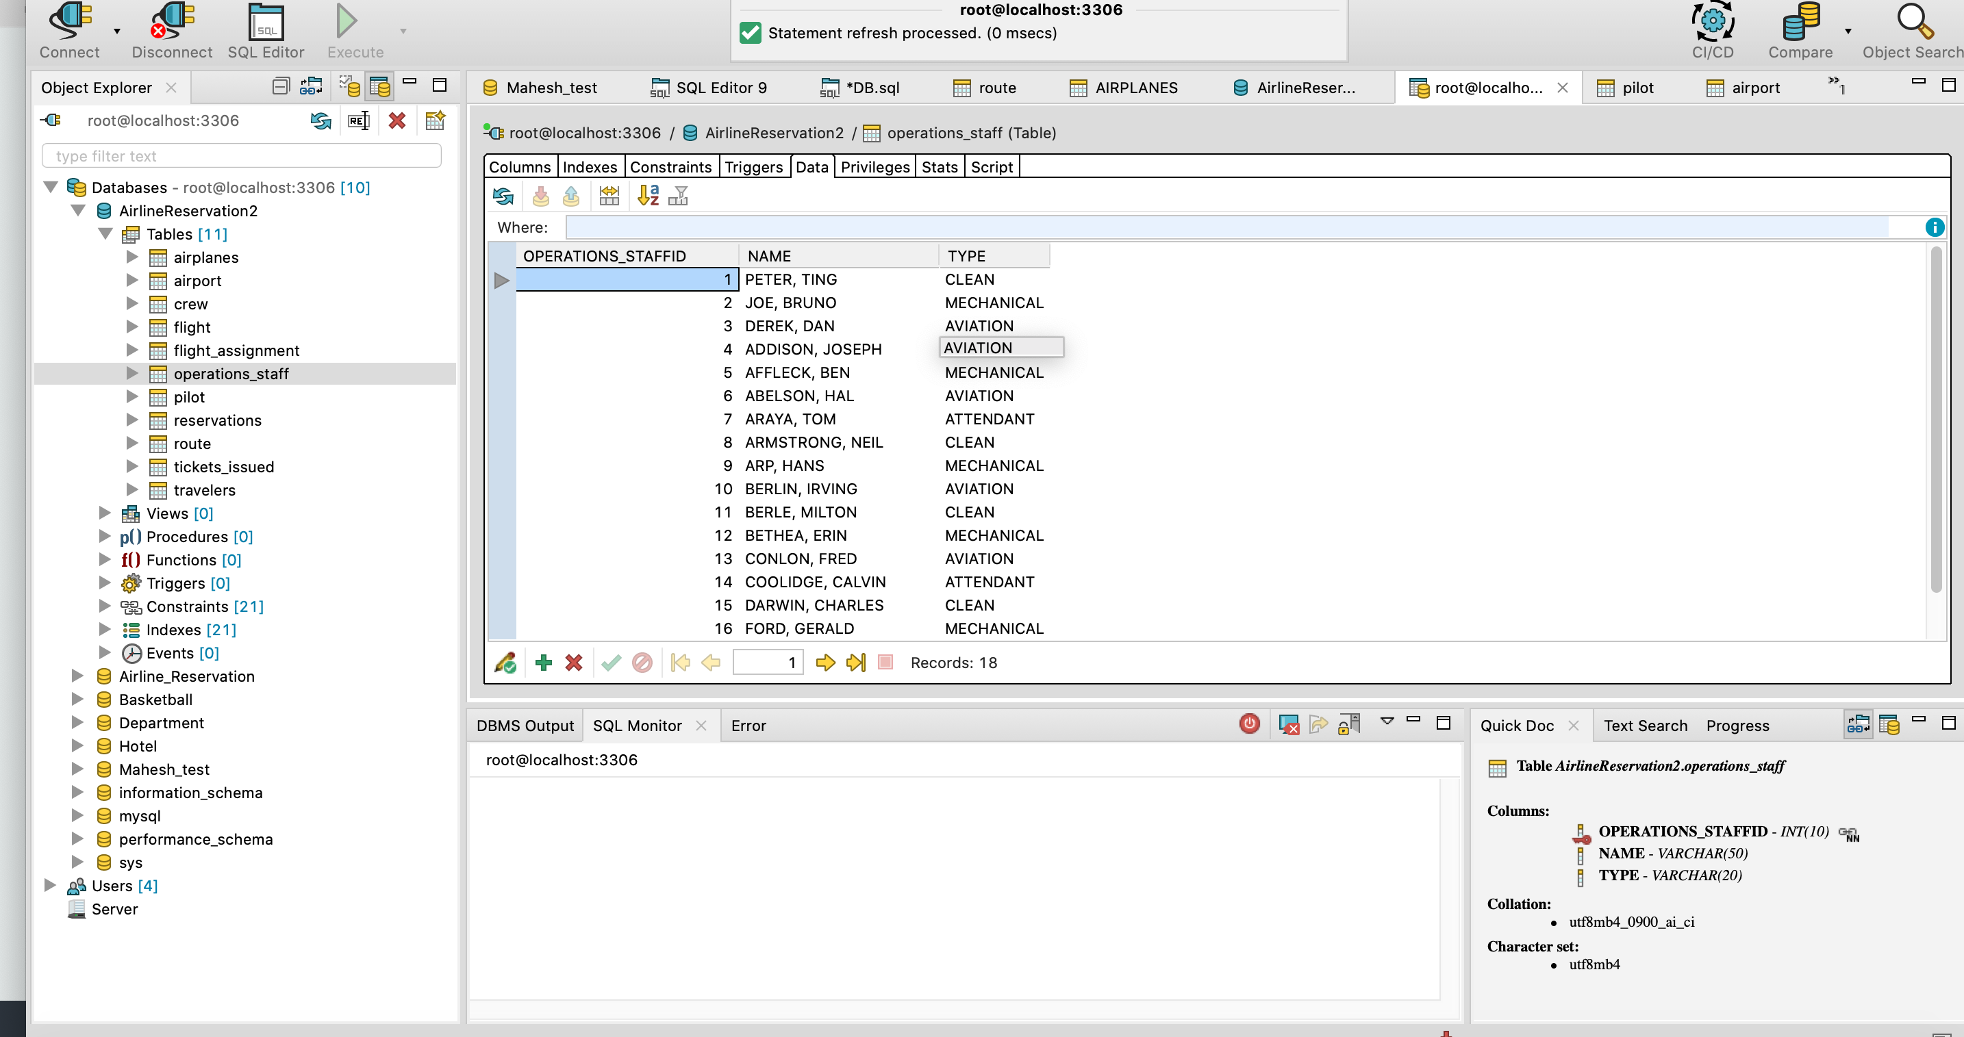Operations_staff:

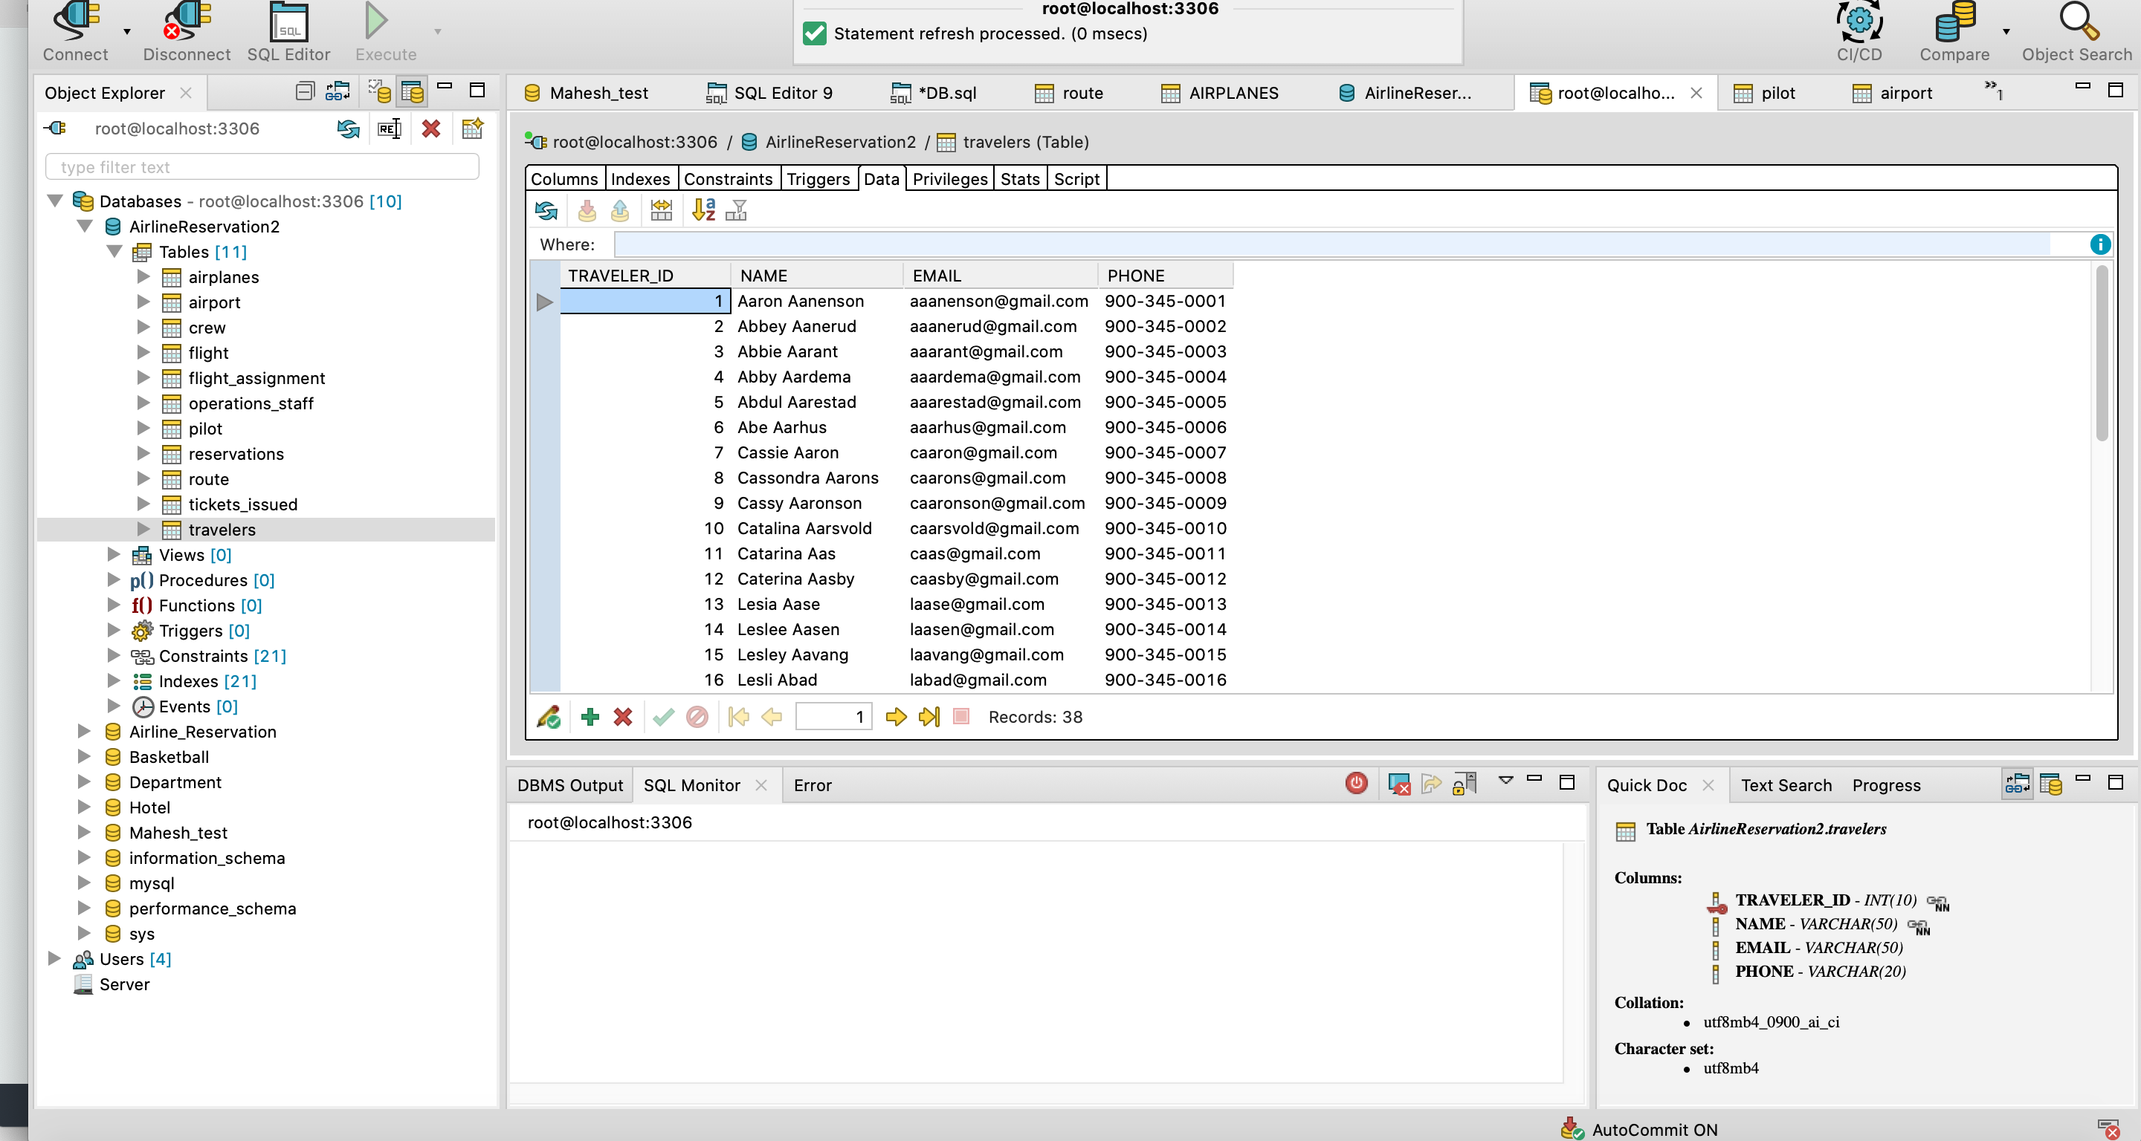Travelers:

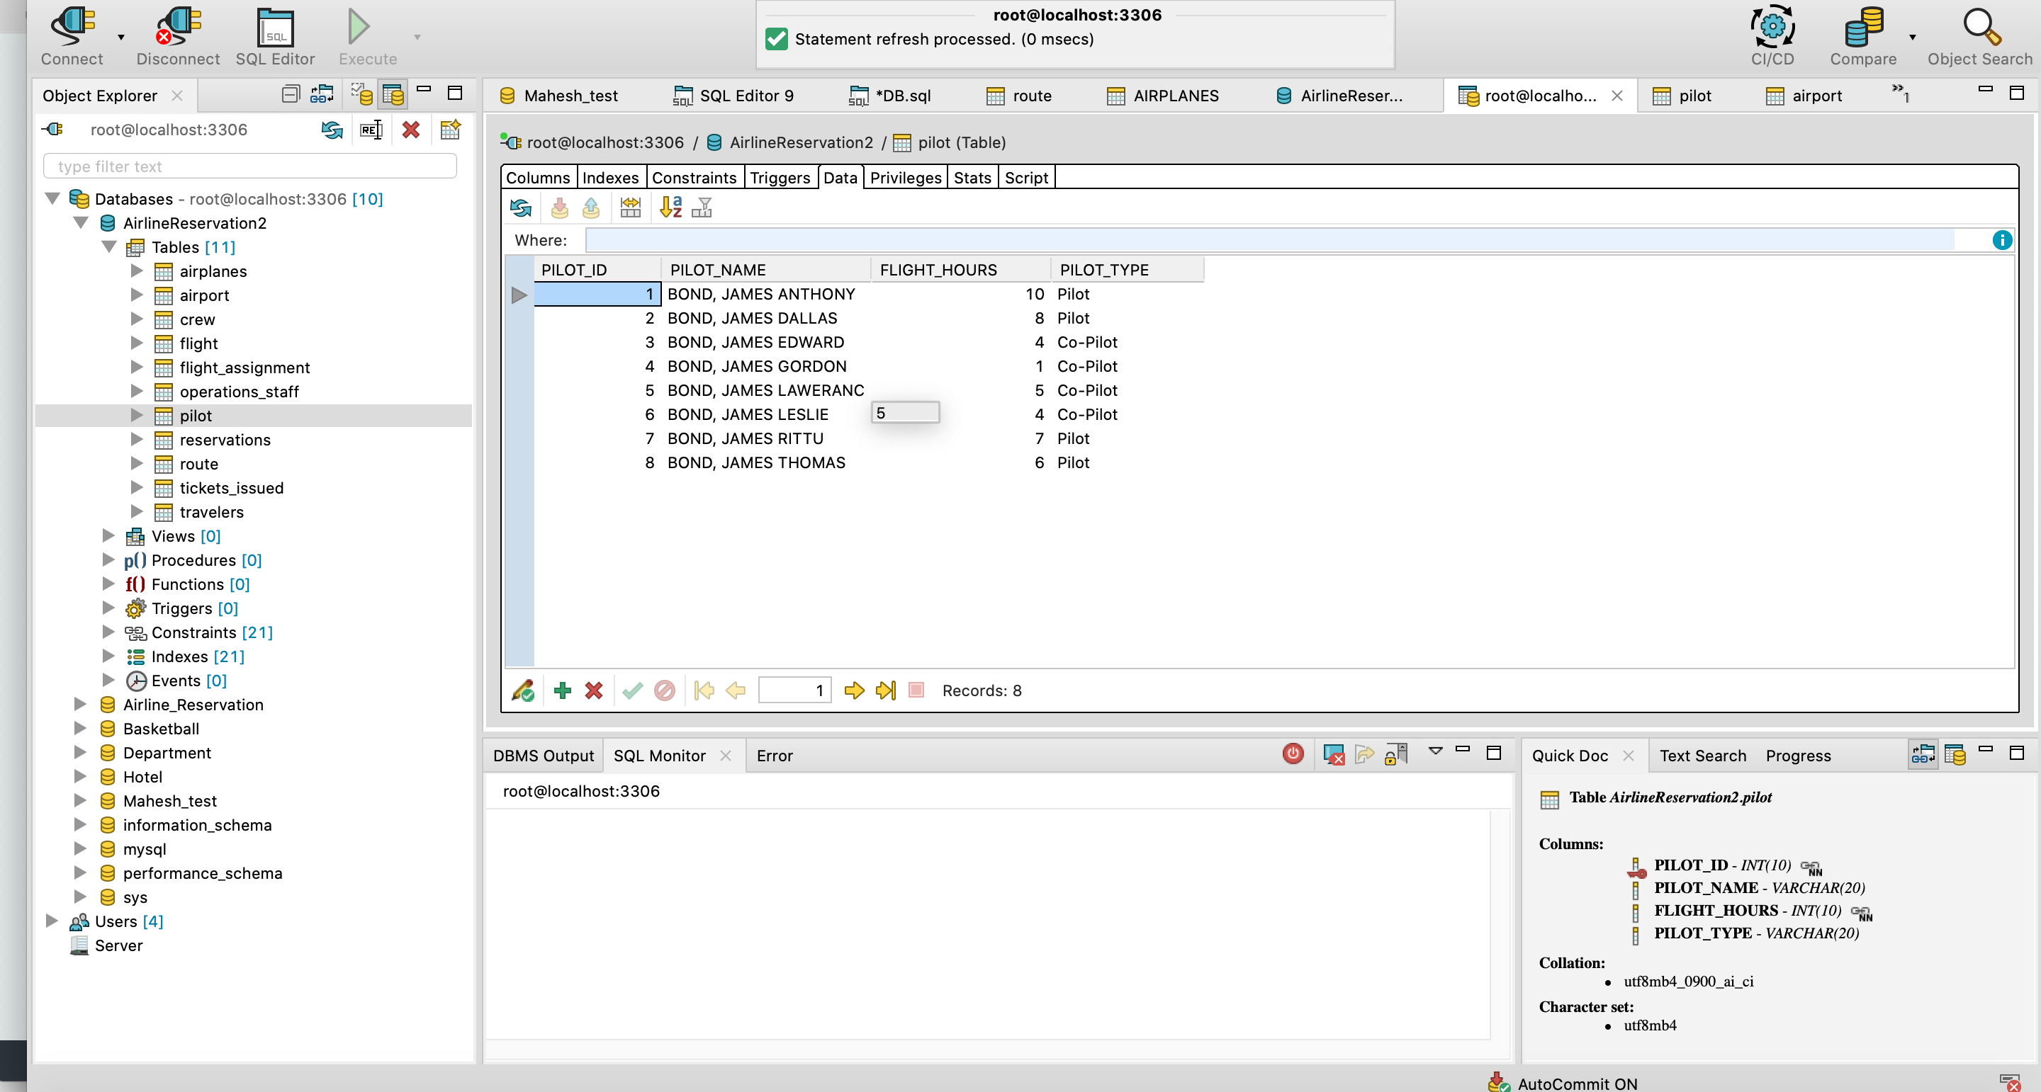Pilot:

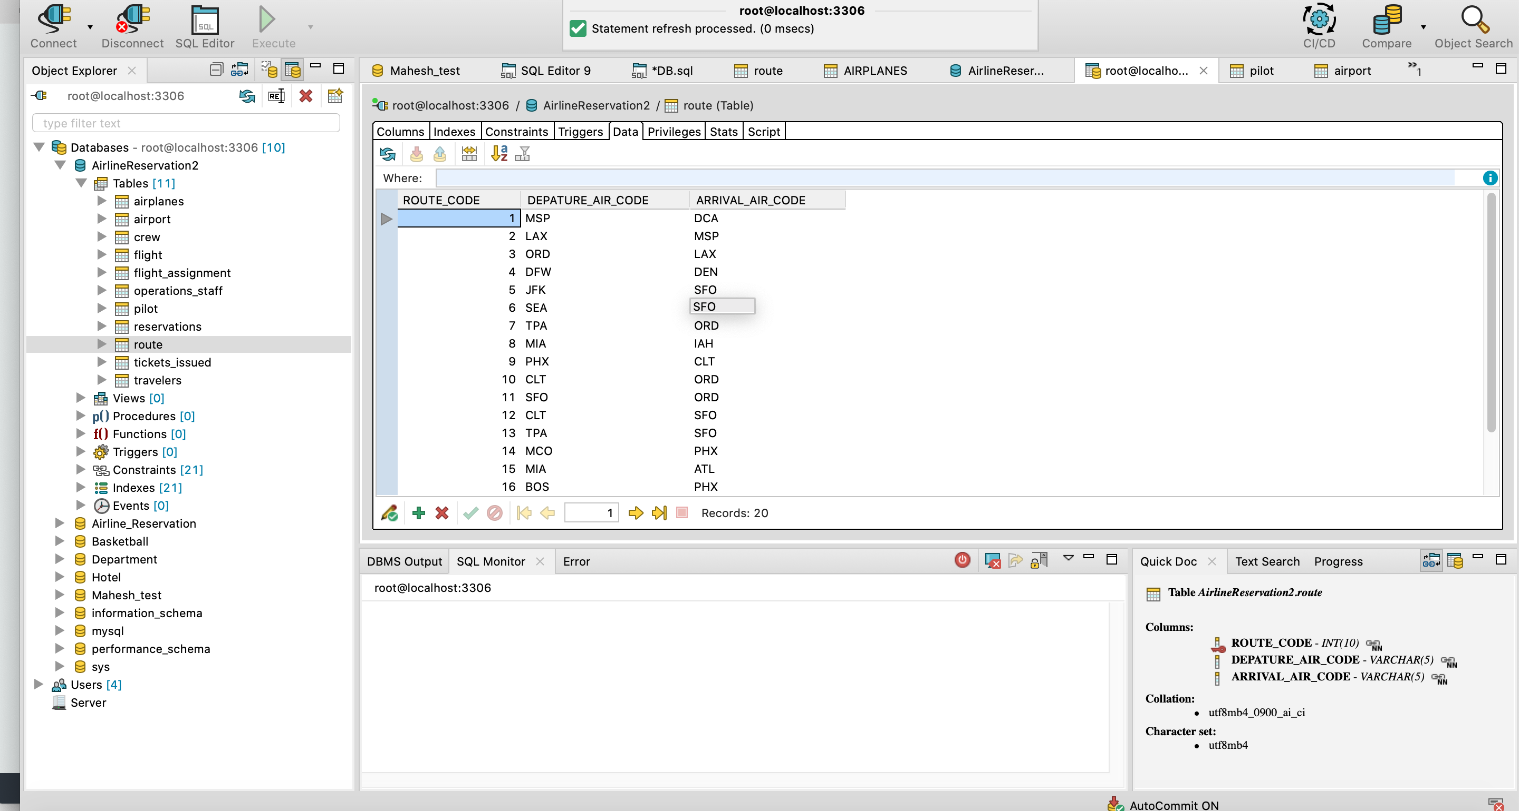Route: